Community Responsiveness to the Feasibility of the Yogyakarta-Semarang Railway Via Magelang Reactivation Program

Amalia Khusnaya

*Department of Public Policy and Management, Faculty of Social and Political Sciences, Universitas Gajah Mada, Yogyakarta, Indonesia.*

Ambar Teguh Sulistiyani

*Department of Public Policy and Management, Faculty of Social and Political Sciences, Universitas Gajah Mada, Yogyakarta, Indonesia.*

Titis Dewi Anggalini

*Department of Public Administration Faculty of Social Sciences, Universitas Negeri Yogyakarta, Yogyakarta, Indonesia.*

|  |  |  |
| --- | --- | --- |
| ARTICLE INFO |  | ABSTRACT |
| *Article history:* |  | This study aims to assess the feasibility of the Jogjakarta-Semarang railway reactivation program via Magelang. The research method used is a quantitative method through surveys and qualitative methods using interview techniques. Feasibility is assessed from 4 aspects, namely aspects of need, technical, management and law, and social aspects. The survey results were processed using Microsoft Excel 2010 applications. Qualitative analysis was strengthened by data triangulation techniques. The findings of this study indicate that the Jogjakarta-Semarang railway reactivation program via Magelang is feasible in two aspects, needs and management and law. While it is considered not feasible according to technical and social aspects. However, reactivation programs should continue to be carried out because future regional developments require alternative modes of transportation. To overcome this, researchers recommend a middle ground, namely 1) Partial reactivation; 2) Development of elevated lines; 3) Policy of swap with additional compensation. Generally, commuters responds positively to railway reactivation programs, but if the railway tracks hit a functional building that exists, then commuters have several considerations. |
| Received 20 April 2020  Received in revised form 27 April 2020  Accepted 29 April 2020 |  |
| *Keyword:* |  |  |
| community’s response; railway reactivation; commuter |  |  |

Introduction

The government as a service provider is obliged to provide facilities to the community to fulfill their life needs. Public transportation is a way of life. The results of annual evaluation studies in the transportation sector in Indonesia are known to have relatively low quantity and quality, so it is necessary to increase service capacity. On the other hand, the accessibility and safety of the community to transportation services also need to be considered. The train is a one-mode route that is expected to answer these needs.

Recently, many improvements have been made to the railway transportation mode, both at the management level, line facilities, and technical operations. Major changes were made under the leadership of the President Director of PT Kereta Api Indonesia (PT KAI), i.e. Ignasius Johan. The railway revolution by adding air conditioning facilities for all economy trains is one of the breakthroughs (Agustio, 2018) and the construction of double tracks, especially in the Java region. Another breakthrough is the railway reactivation program in Java and Sumatra. In March 2019, the Pariaman-Naras railway line was inaugurated by the Minister of Transportation, Budi Karya Sumadi. This line is one of the railway lines in Indonesia that has been successfully reactivated. The railway reactivation program is new and rare, as it is only found in Indonesia. The program has been discussed since 2004 and started in 2017.

**Figure 1. Number of Vehicles Along Main Roads Jogjakarta-Semarang via Magelang 2014-2017 (per August)**

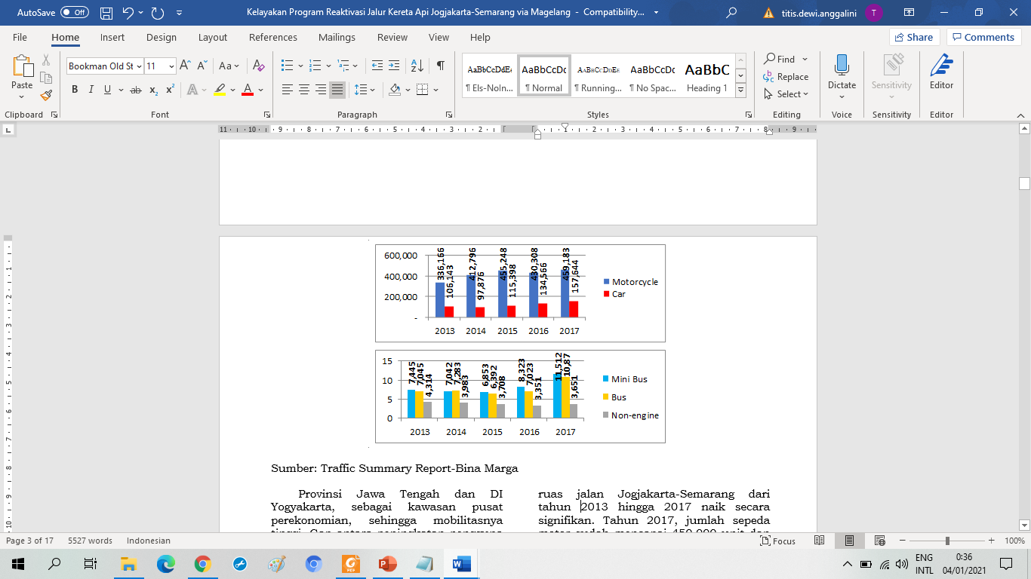

Source: Traffic Summary Report-Bina Marga, 2019

Reactivation is the reuse of a number of old train tracks (Anggriawan, 2013: 1), which were deactivated within a certain period of time, but technically it is deemed feasible to operate again. This policy is an alternative to the transportation network to ease the burden on a very congested road network (Fuadi et al., 2014: 696-697). The concept of railway reactivation is a refunctionalization perspective. Reactivation of railway lines is interpreted as an activity to reactivate railways that still have potential but are not being operated (Directorate General of Railways, 2011), as a form of strategy to reuse inactive resources.

Reactivation is increasingly important given the development of territory and population. Mass transporter is needed to accelerate accessibility from origin to destination. Regional development always has a reciprocal relationship to population mobility (Zalinsky, 1971; Hugo, 1975; Todaro, 1978; Simon, 1984; Mantra, 1978; Sunarto, 1991 in Zubaidah, et al, 2015: 5). The developing region has become a magnet for people to achieve a better life expectancy, resulting in urbanization. The majority of villagers with low economic levels move to cities, but not all have access to the jobs or education they want. Even migrants have to bear higher living costs. Cities are getting denser, land is limited so that land prices are increasingly high. Rail reactivation is the solution to controlling urbanization. With reactivation, the distance, time, and cost of the round trip become rational. From this phenomenon, circular mobility emerged (Hidayati, 2018) or commuting. Commuter behavior is highly dependent on the distance between the origin and destination areas (Rustariyuni, 2013: 98). The closer the origin and destination areas are, the greater the likelihood of a round trip.

As the times and population develop, the number of vehicles increases, so that the traffic volume is getting higher. Meanwhile road capacity remains. One of the cases occurred on the Jogjakarta-Semarang road via Magelang.

Central Java Province and Yogyakarta Special Region, as the economic center areas, have high mobility. The gap between the increase in road users and fixed road conditions has resulted in limited vehicle speed, experiencing obstacles, resulting in congestion. Figure 1 The number of vehicles on the Jogjakarta-Semarang road from 2013 to 2017 has increased significantly. In 2017, the number of motorbike have reached 450,000 units and car more than 150,000 units. This condition will get worse due to population growth, as can be seen in Figure 2.

The density of the Jogja-Semarang roads is caused by commuters who tend to use private vehicles rather than using public transportation (Mann, 2006). Private vehicles are chosen because of the freedom they get (Mann, 2006: 161), the reasons for convenience (DiGuiseppi et al., 1998; Eom et al., 2009; Wilson et al., 2010) are a priority factor in determining the mode of transportation. This reason is a challenge in public transport policy. Commuter flexibility and comfort are met in accessing public transportation (Mann, 2006: 163). Meanwhile, public transportation such as buses and travel is a risky option. Even though the bus has a fixed and definite schedule, the congested road conditions make commuter arrival times at their destination unpredictable. Alternative modes of transportation according to today's needs are travel times that are fast, precise, and do not operate on the highway.

**Figure 2. Total Population of DI Yogyakarta and Central Java Provinces**

**2012-2016**

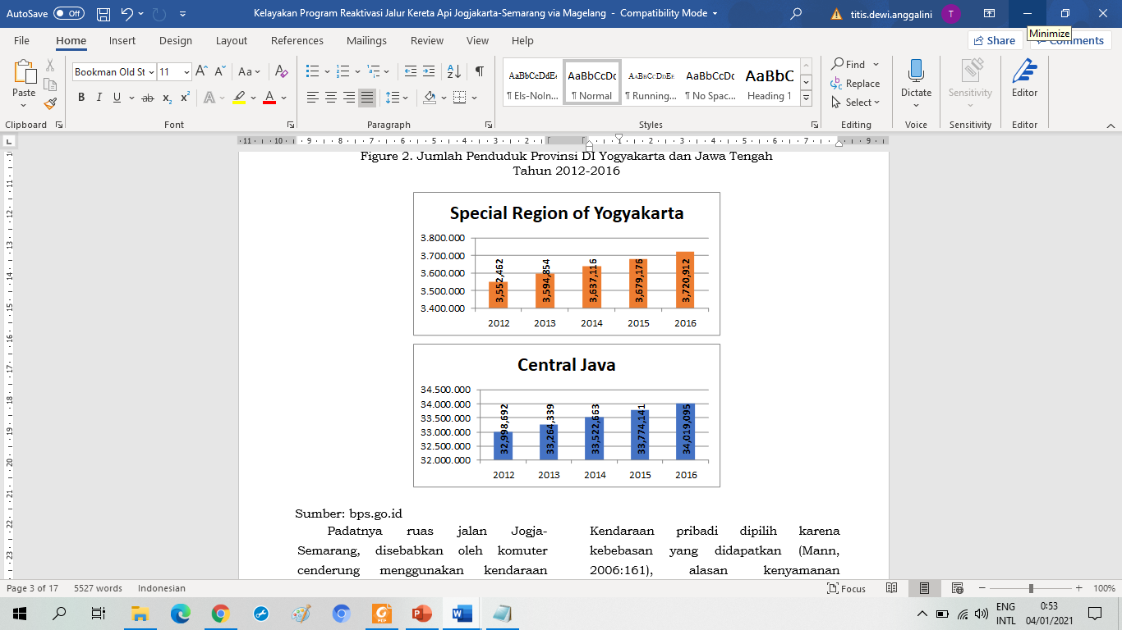

Source: Central Bureau of Statistics, 2019

The cost factor is also considered by commuters (DiGuiseppi et al., 1998; Eom et al., 2009; Pabayo et al., 2008), price (DiGuiseppi et al., 1998; Eom et al., 2009; Pabayo et al., 2008) security (DeBoer, 2005; Ettema et al., 2011; Pabayo et al., 2008), knowledge (Rong-Chang et al., 2013; Lin et al., 2012), and manners (Beck et al. , 2013; Eom et al., 2009; Lucidi et al., 2013; Wilson et al., 2010; Xiao et al., 2013). Commuter behavior tends to consider time-efficient and comfortable modes of transportation. Train is the mode of transportation most relevant to commuter expectations.

Answering this problem, the government is trying to encourage the use of subsidized public transportation for commuters, so it is worth considering. Not all modes of transportation are subsidized, for example buses are not subsidized by the government, because they are managed by the private sector (Teal, 1978). With the bus mode of transportation, commuters have to spend more than twice as much as trains. For example, for the Jogja-Solo Prameks Train, the ticket price is IDR 8,000, because it is subsidized, while the AC bus ticket costs IDR 20,000. By rail, commuters can save 60%.

In addition to economizing on commuting, it is also easier to access, because trains are able to carry large amounts of cargo and passengers for long and medium distances (Nazwirman, 2017: 27). It is said that the load that can be loaded in 1 trip is equivalent to 20 buses for passenger transportation and 40 trucks for goods transportation (Kencana, 2018).

The reactivation of the railway line as a heritage asset of the Netherlands, aims to optimize resource utilization. This is a noble goal, even if the realization is not easy. Since its abandonment in 1975, the Jogjakarta-Semarang via Magelang railway has been damaged, some parts of the track have been lost, and functional buildings have been buried. This was also experienced by the Cirebon-Kadipaten railway reactivation program. Reactivation is hampered, because most of the rails have been lost and the land as railway lines has been converted into houses for residents (Anggriawan, 2013). The reactivation of the Muaro Kalaban-Muaro Sijunjung railway line which has not been operated for + 30 years, the land along the railway tracks has turned into a lot of settlements, so the reactivation program has received a lot of resistance from the community (Erniwati, 2016). The implementation of the railway reactivation program faces obstacles in the field. Besides the assets have changed their function, the management and management have also shifted. This condition also affects the reactivation program of the Jogjakarta-Semarang railway via Magelang. Given the reactivation of railways as a new and rare case, as well as the existence of many field constraints, until now there has not been much research and publication. This article reveals the community's response to the feasibility of the reactivation program for the Jogjakarta-Semarang railway via Magelang. The feasibility of the program is seen from 5 aspects, namely needs, technical, management, legal, and social aspects. Based on commuter responsiveness to the feasibility of the program, recommendations can be formulated for the implementation of reactivation of the Jogjakarta-Semarang railway via Magelang.

Methods

This research uses a quantitative approach with a survey method. The research instrument of the questionnaire was structured with a closed model using a Likert scale. The questionnaire was distributed to 60 respondents as a sample with a purposive sampling technique, in which the respondents were selected based on the categories they were looking for. The questionnaire questions have been tested using the Corrected Item-Total Correlation technique with the amount of data (n) = 60 at a significance of 0.05, so that r table is 0.165. From the test results, it is found that 22 questions have a correlation, or are valid and can be used for research. Reliability test, obtained the value of Crobach's Alpha = 0.796> 0.60, so that 22 questions proved to be reliable.

Respondents are people from Jogjakarta, Magelang or Semarang who routinely commute the Jogjakarta-Semarang route via Magelang with characteristics as can be seen in Table 1. Questionnaires are distributed online in the form of google form which is distributed through social media in the form of Whatsapp, Line, Twitter and by e-mail.

The unit of analysis for this research is the Government Program, namely the Yogyakarta-Semarang Railway Reactivation Program via Magelang. The questionnaire results were entered into the Microsoft Excel 2010 application system, then classified, tabulated, interpreted and analyzed according to the indicators. To refine the quantitative data findings, in-depth interviews were conducted regarding reactivation policies with stakeholders, namely the Class 1 Railway Engineering Center for Central Java Region; Special Region of Yogyakarta Provincial Transportation Office; and the Transportation Department of Central Java Province.

Reaserch Result

**Table 1. Respondent Information**

|  |  |  |  |  |  |  |
| --- | --- | --- | --- | --- | --- | --- |
| Description | | Total |  | Description | | Total |
| Occupation | Civil Servants | 5 |  | Income | More than IDR 10,000,000 | 3 |
| Privat Employee | 13 |  | IDR 5,000,000 – 10,000,000 | 4 |
| Student | 40 |  | IDR 3,000,000 – 5,000,000 | 6 |
| Not working | 2 |  | IDR 1,600,000 – 3,000,000 | 9 |
| Education | Diploma/Bachelor Degree | 31 |  | Less than IDR 1,600,000 | 38 |
| Non Diploma/Bachelor Degree | 29 |  | Sex | Man | 26 |
|  |  |  |  | Woman | 34 |

Source: Analysist, 2019

The reactivation program of the Jogjakarta-Semarang railway via Magelang was launched by the Directorate General of Railways, Ministry of Transportation of the Republic of Indonesia which is regulated in the Decree of the Minister of Transportation of the Republic of Indonesia Number 2128 of 2018 concerning the National Railway Master Plan. There is a clear division of tasks between institutions, both regarding planning-development and operations (Technical Staff for Railway Activities and Development, Class 1 Railway Engineering Center for Central Java Region). All planning and development for the development of railway infrastructure is under the responsibility of the Directorate General of Railways, while regarding operations is under the responsibility of PT Kereta Api Indonesia (PT KAI).

In its implementation, the reactivation program involves at least 3 parties, namely the Ministry of Transportation of the Republic of Indonesia, the Provincial Government of Central Java, and the Provincial Government of DI Yogyakarta (KASI Railway, Central Java Province Transportation Service). Furthermore, the portion of this involvement varies at each stage. In planning, all have the same portion to be involved in the feasibility study and the alignment plan. From the feasibility study, a reactivation plan for the Jogjakarta-Semarang railway via Magelang is produced as shown in Figure 3.

In the feasibility study document (Ministry of Transportation of the Republic of Indonesia, 2018) it is known that the Jogjakarta-Semarang railway via Magelang will be reactivated covering 16 stations, namely Patukan, Sleman, Tempel, Muntilan, Palbapang, Kota Magelang, Secang, Bedono, Ambarawa, Tuntang, Beringin, Gogodalem, and Kedungjati which are on one line, plus 3 canal stations namely Borobudur for tours, Depo Pasir in Salam, and Dipo Art in Mungkid.

**Figure 3. The plan for the Yogyakarta-Semarang Railway Line via Magelang to be reactivated**

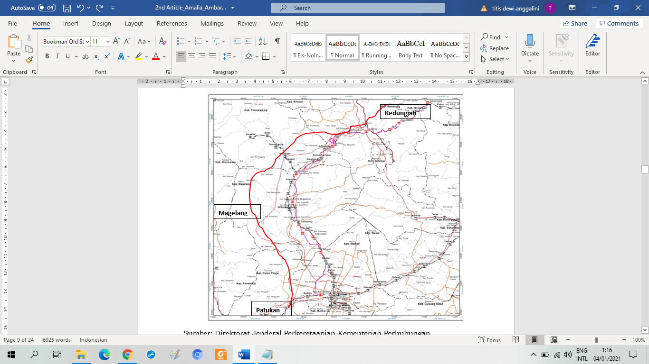

Source: Directorate General of Railways-Ministry of Transportation, 2019

After conducting a traceability study at the end of 2018, the Directorate General of Railways then made adjustments to the Regional Spatial Plans of each Regency / City that the railway traversed through a coordination meeting that lasted until April 2019 (Head of Railway Section, Provincial Transportation Office Central Java). After the alignment is agreed upon by the regions, a Detailed Engineering Design (DED) can be prepared followed by an Environmental Impact Analysis Study (EIA). If the results of EIA's recommendations are valid and meet the physical, social, and environmental requirements to reactivate the Jogjakarta-Semarang railway via Magelang, then land acquisition can be carried out. In the construction phase, the Directorate General of Railways will delegate authority to the Railway Engineering Center which is an extension of the regions.

**Figure 4. Scheme of Planning and Construction Work Sharing in the Reactivation Program of the Jogjakarta-Semarang Railway Via Magelang**

Source: Analysist, 2019

The Jogjakarta-Semarang railway via Magelang will be operated as a commuter train between Kedungjati and Patukan Stations, which will make a round trip from one end to the other. With the presence of this railway line, it is hoped that it can reduce the burden on the road network that is already experiencing congestion. Furthermore, the route will be developed to connect between 3 airports, namely Yogyakarta International Airport (YIA) in Jogjakarta, Adi Sumarmo Airport in Solo, and Ahmad Yani Airport in Semarang.

Commuter Response to the Feasibility of the Jogjakarta-Semarang Railway Reactivation Program via Magelang. The commuter response to the reactivation program of the Jogjakarta-Semarang railway via Magelang is divided into 3 indicators, which are seen from the following attitudes, responses, and actions:

*Attitude*

This program received positive attitudes from respondents. The majority of respondents gave a statement that they strongly agreed with the implementation of the reactivation program.

Table 2. Commuter Response to Attitude Indicator

|  |  |  |
| --- | --- | --- |
| Attitude | Total | % |
| Strongly Agree | 33 | 55% |
| Agree | 17 | 28,3% |
| Netral | 8 | 13,3% |
| Disagree | 1 | 1,7% |
| Strongly Disagree | 1 | 1,7% |
| **Total 60 Respondent** | | |

Source: Analyst, 2019

*Response*

Community response in the form of responses can be seen from the respondent's assessment of the presence of the reactivation program. Respondents' positive evaluation of the reactivation program was even seen as a visionary and strategic policy.

**Table 3. Commuter Response to Response Indicator**

|  |  |  |
| --- | --- | --- |
| Assesment | Total | % |
| Visionary policy | 16 | 26,7% |
| Strategic policy | 40 | 66,7% |
| Good policy | 1 | 1,7% |
| Controversial policy | 3 | 5% |
| **Total 60 Respondent** | | |

Source: Analyst, 2019

*Action*

Community action as a response to the reactivation program is judged by the enthusiasm of the community for operationalization in the future. Most of the respondents will switch from the current mode of transportation to the train for the return trip from Jogjakarta to Semarang via Magelang.

**Table 4. Commuter Response to Action Indicators**

|  |  |  |
| --- | --- | --- |
| Action | Total | % |
| Will switch | 58 | 96,7% |
| Will not switch | 2 | 3,3% |
| **Total 60 Respondent** | | |

Source: Analyst, 2019

In giving this response, commuters have several factors to consider, with the most dominant factors being travel time and comfort.

**Figure 5. Commuting Factors to Consider Agree/Disagree Statement**

Source: Analyst, 2019

Respondents with different characteristics from each other gave different responses seen from their attitudes and responses.

Female respondents who approved the implementation of the reactivation program for the Jogjakarta-Semarang railway via Magelang had a larger percentage than male respondents. The percentage of male respondents who are neutral is also greater than that of female respondents. So that according to gender, female respondents tended to agree with the implementation of the reactivation program compared to male respondents.

**Table 7. Characteristics of Residence Distance to Attitude**

|  |  |  |  |  |
| --- | --- | --- | --- | --- |
| **Attitude** | **Distance** | | | |
| Near reactivation site | % | Far From reactivation site | % |
| Strongly Agree | 13 | 46,4% | 20 | 62,5% |
| Agree | 11 | 39,3% | 6 | 18,8% |
| Netral | 4 | 14,3% | 4 | 12,5% |
| Disagree | - | - | 1 | 3,1% |
| Strongly Disagree | - | - | 1 | 3,1% |
| **Total** | **28** | **100%** | **32** | **100%** |

Source: Analysist, 2019

**Table 6. Characteristics of Gender on Response**

|  |  |  |  |  |
| --- | --- | --- | --- | --- |
| **Response** | **Sex** | | | |
| Man | % | Man | % |
| Visionary policy | 7 | 27% | 9 | 26,5% |
| Strategic policy | 17 | 65,4% | 23 | 67,6% |
| Good policy | 1 | 3,8% | - | - |
| Controversial policy | 1 | 3,8% | 2 | 5,9% |
| **Total** | **26** | **100%** | **34** | **100%** |

Source: Analysist, 2019

**Table 5. Characteristics of Gender on Attitude**

|  |  |  |  |  |
| --- | --- | --- | --- | --- |
| **Attitude** | **Sex** | | | |
| Man | % | Man | % |
| Strongly Agree | 15 | 57,7% | 18 | 52,9% |
| Agree | 6 | 23% | 11 | 32,3% |
| Netral | 4 | 15,4% | 4 | 11,8% |
| Disagree | 1 | 3,9% | - | - |
| Strongly Disagree | - | - | 1 | 3% |
| **Total** | **26** | **100%** | **34** | **100%** |

Source: Analysist, 2019

Female respondents and male respondents have the majority of the same assessment, namely assessing it as a strategic program. The tendency of male and female respondents to assess reactivation programs is the same, leading to positive policies. However, female respondents who considered the program to be a controversial policy were greater than male respondents.

Both respondents who live close to the old Jogjakarta-Semarang railway via Magelang and respondents who do not live close to each other tend to agree with the implementation of the reactivation program. Almost the majority of respondents who do not live close to each other strongly agree with the implementation of the program, and a few who are neutral or tend to disagree with the implementation of the program. In contrast to respondents who live close to each other, namely respondents who strongly agree and only agree have almost the same percentage.

**Table 9. Characteristics of Occupation on Attitude**

|  |  |  |  |  |  |  |  |  |
| --- | --- | --- | --- | --- | --- | --- | --- | --- |
| **Attitude** | **Education** | | | |  |  |  |  |
| Civil Servants | % | Privat Employee | % | Student | % | Not working | % |
| Strongly Agree | 3 | 60% | 9 | 69,2% | 21 | 52,5% | - | - |
| Agree | 1 | 20% | 3 | 23,1% | 11 | 27,5% | - | - |
| Netral | 1 | 20% | 1 | 7,7% | 6 | 15% | 2 | 100% |
| Disagree | - | - | - | - | 1 | 2,5% | - | - |
| Strongly Disagree | - | - | - | - | 1 | 2,5% | - | - |
| **Total** | **5** | **100%** | **13** | **100%** | **40** | **100%** | **2** | **100%** |

Source: Analysist, 2019

**Table 8. Characteristics of Education on Attitude**

|  |  |  |  |  |
| --- | --- | --- | --- | --- |
| **Attitude** | **Education** | | | |
| Bachelor/  Diploma | % | Non Bachelor/ Diploma | % |
| Strongly Agree | 18 | 58% | 15 | 51,7% |
| Agree | 10 | 32,3% | 7 | 24,1% |
| Netral | 2 | 6,5% | 6 | 20,7% |
| Disagree | - | - | 1 | 3,5% |
| Strongly Disagree | 1 | 3,2% | - | - |
| **Total** | **31** | **100%** | **29** | **100%** |

Source: Analysist, 2019

Judging from the educational characteristics, both Bachelor/Diploma and Non-Bachelor/Diploma respondents, the majority strongly agreed with the implementation of the program. However, Non Bachelor/Diploma respondents have a greater percentage of neutral attitudes than Bachelor/Diploma respondents. The percentage of Bachelor/Diploma respondents who tended to approve the implementation of the reactivation program was greater than that of Non Bachelor/Diploma respondents. However, there are still Bachelor/Diploma respondents who do not agree with the implementation of the program.

The biggest difference in attitude was shown by respondents who had jobs, either as civil servants, private employees or students, compared to respondents who did not work. The majority of respondents who work agree with the implementation of the program, while respondents who do not work choose to be neutral.

Discussions

Viewed from the aspect of community needs, it can be assessed from the demand. As many as 26.7% of respondents still use buses because they do not own a motorbike or car and bus fares are cheaper than other public transportation (travel). Another reason for respondents is that only buses serve routes from their origin to their destination.

With no other alternative, the respondent chose the bus. Therefore, most respondents agree with the railway reactivation program. The presence of trains is more prospective as an alternative transportation to support mobilization. Trains do not operate on the roads, but have special rails so they are free from congestion, and travel time is faster. Railway facilities are also getting better, so that they are able to answer the needs of commuters that cannot be found in other modes. Nazwirman's research (2017) states that public interest in transportation modes is increasing from year to year, as well as in rail transportation modes.

Technical aspects are also assessed from program implementation. In practice, the reactivation program does not always go according to plan. The route has been abandoned for decades, some have changed function, and some others have been damaged or lost. One of the cases of the railway line that will be reactivated has changed its function, namely along the Jombor to Denggung section which currently has become one of the main road networks connecting Jogjakarta with Semarang via Magelang. The losses that will be caused by the diversion and even the closure of the road segment will certainly be very large, as will the potential for social conflict between the government and the community. By diverting traffic, the economy of the area around the old road will slowly die, as happened to the Pantura route after the emergence of the Trans Java toll road (Kompas, 2017). Road users, face problems either travel time or changing terrain. Commuters and entrepreneurs in general, have chosen the most suitable and quickly accessible way to get to their destination (Indah et al, 2015: 314). In Magelang City, there is a change in the function of owned land

PT KAI has become a public space, namely a market. The search results show that there is a former platform building at Rejowinangun Market. Around Rejowinangun Market there is also PT KAI's land which has been turned into a shopping area, especially along Jalan Pemuda to Magelang City Square or better known as the "shopping" area. In 2002, there was a discourse that the Magelang City Government requested land ownership rights from PT KAI, but there has been no further information to date (Kompas, 2011). This case shows a violation of regulations committed by the Magelang City Government on the use of land belonging to PT KAI.

**Table 10. Types of Transportation Used by Respondents**

|  |  |  |  |
| --- | --- | --- | --- |
| Type of Transportation | Total | % | |
| Car | 2 | 3,3% | |
| Motorcycle | 40 | 66,7% | |
| Online / conventional motorcycle taxis | 2 | 3,3% | |
| Bus | 16 | 26,7% | |
| **Total 60 Respondent** | | |

Source: Analysist, 2019

The Rejowinangun market has allegedly been around since 1982 (Kompas, 2017) and continues to grow until now. In 2008, there was a fire which was later repaired in 2011. On the one hand, the impression was that PT KAI allowed its land to be used by the Magelang City Government because there was already a large enough market, it had even been inaugurated as a National Standard Market by the National Standardization Agency (BSN) since February 2019 (Ferri K, 2019). On the other hand, PT KAI shifted the railway line to be rebuilt a few hundred meters to the East as shown in the plot. This new line will not hit Rejowinangun Market and shopping areas. This further adds to the impression that PT KAI has succumbed to the City Government of Magelang and shows the government's weak supervision and inventory of assets owned.

Management and legal aspects are assessed from the organizational structure and legal basis they have. The reactivation program of the Jogjakarta-Semarang railway via Magelang is under the responsibility of the Directorate General of Railways-Ministry of Transportation of the Republic of Indonesia. In the implementation process, there is a division of labor according to the authorities they have. From a legal basis, this reactivation program is listed in the Decree of the Minister of Transportation of the Republic of Indonesia Number 2128 of 2018 concerning the National Railway Master Plan.

The social aspect is assessed from the response given by the community to the implementation of the reactivity program. In general, the community responds positively when the railway line does not crash into an existing functional building. However, if the reactivation path crashes into a functional building, the respondent proposes several considerations. First, the government must coordinate with stakeholders and the community, take route diversion or re-planning.

In fact, the implementation of coordination among stakeholders is faced with many conflicting interests. For that we need a middle way that is able to facilitate stakeholders, so that no interests are sacrificed.

**Figure 7. Respondents' Considerations When the Reactivation Path Crashes into Settlements or Public Spaces**

Source: Analysist, 2019

**Figure 6. Respondents' Considerations When the Reactivation Path**

**Hits the Road**

Source: Analysist, 2019

The second consideration, if the reactivation of the railway crashes into settlements or public spaces, the government must move the affected settlements and public spaces (swap and roll) with additional compensation money. The most sharp response from commuters was to suggest re-planning so as not to disturb the existing functional building. Very few respondents suggested carrying out eviction.

From these 2 findings, respondents who considered the re-planning of the reactivation program of the Jogjakarta-Semarang railway via Magelang if they hit a residential area, almost doubled from the first consideration. This shows that the community supports government programs as long as the program does not harm the community, both socially and financially. This program still has the potential for social conflict between the community and the government. Many people have complained and are restless because it is not clear whether their place of residence has not been evicted. The DI Yogyakarta Transportation Agency stated that almost all old railway lines to be reactivated have built buildings, making it very difficult to reactivate. Meanwhile, the availability of vacant land is very limited. A possible alternative to constructing an elevated railway line, or a track built on top of a building in general.

**Table 10. Results of a Feasibility Study on the Railway Reactivation Program**

**Yogyakarta-Semarang via Magelang**

|  |  |  |  |  |  |
| --- | --- | --- | --- | --- | --- |
| No | Aspect | Fact | Worthiness | | |
| Worthy | Lack worthy | Not Worthy |
| 1 | Need | * Demand for a faster and more convenient mode of transportation * A faster mode of transportation as a community choice | V |  |  |
| 2 | technical | * Several lines have been converted into roads * Several railway lines have been buried in functional buildings |  | V |  |
| 3 | Management | * The organizational structure during construction and operation has been clearly drawn up | V |  |  |
| 4 | Juristic | * The legal basis for implementing the reactivation program already exists | V |  |  |
| 5 | Social | * There is a potential for social conflict with the community, because some of the old railway lines have been converted into settlements |  | V |  |

Source: Analysist, 2019

The results of a study on the feasibility of the reactivation program for the Jogjakarta-Semarang via Magelang railway in 5 aspects, namely aspects of need, technical, management, law, and social aspects are briefly presented in Table 11

The railway reactivation program is not fully feasible, especially in terms of technical and social aspects. Given the growth of the Jogjakarta region with the presence of YIA and Semarang as centers of economic growth in Central Java as well as port cities, it makes connectivity between the two regions important. The road network was no longer able to accommodate the increasing volume of transportation so that congestion began to occur. It is predicted that in 2035, the population of Central Java will reach 37 million and DI Yogyakarta will reach more than 4.3 million, causing the flow of mobilization from the two regions to increase. To support the maximum mobility of the community, the presence of rail transportation is still needed. The government should overcome technical and social obstacles so that the reactivation program of the Jogjakarta-Semarang railway via Magelang can continue.

Conclusion

In connection with the theory of 5 non-financial feasibility aspects from the research results of Hotma (2014), Poetri et al (2014) and Wildan (2014), the reactivation program of the Jogjakarta-Semarang railway via Magelang is considered feasible to be implemented from the aspects of need and management aspects. and law. The value of the legality of a program is very important as the foundation for reactivation of railways. Based on the projected population growth in Central Java and Special Region of Yogyakarta Provinces, it is mandatory to be supported by rail transportation modes. Aspects of feasibility needs as well as management and law are met, so the railway reactivation program is feasible to be implemented. The community explicitly provides conditional support, namely examining parts of assets that have changed functions by providing a transfer of route or swap solutions.

The middle ground that needs to be done so that the technical and social aspects can be overcome, then the reactivation of the Jogjakarta-Semarang railway via Magelang is feasible with the following alternatives: Reactivation of the railway line is carried out elevated with the consequence that the cost of the reactivation program will be greater; Reactivation of railway lines is carried out partially, namely only on lines that do not require displacement of functional buildings, re-planning or constructing new, building-free lines; or displacement of affected communities and public spaces (exchange of roll) by being given additional compensation money, by reducing social conflicts.

References

**Books**

Adisasmita, R. (2006). “Pembangunan Pedesaan dan Perkotaan”, Yogyakarta: Graha Ilmu.

Direktorat Jenderal Perkeretaapian. (2011). Rencana Induk Perkeretaapian Nasional.

Direktorat Jenderal Perkeretaapian. (2017). Reviu Rencana Strategis Kementerian Perhubungan Bidang Perkeretaapian 2015-2019, Jakarta.

Hotma, R. (2014). Analisis Kelayakan Usaha Restoran Momomilk di Taman Kencana Kota Bogor, Skripsi, Institut Pertanian Bogor.

Kementerian Perhubungan Republik Indonesia. (2009). Studi Pembangunan Sistem Kereta Api Regional Wilayah Jawa Tengah di Indonesia.

Kementerian Perhubungan Republik Indonesia. (2018). Studi Kelayakan Survei Investigasi dan Rancangan Dasar Akses Jalur Kereta Api Menuju Kawasan Strategis Pariwisata Nasional (KSPN) Borobudur dan Sekitarnya.

Poewardaminta. (1987). “Kamus Umum Bahasa Indonesia”, Jakarta: Balai Pustaka.

Undang-undang Nomor 2 Tahun 2012 tentang Pengadaan Tanah Bagi Pembangunan untuk Kepentingan Umum.

Zubaidah et al. (2015). Migrasi Pelajar dan Mahasiswa Pendatang di Kota Pendidikan : Laporan Penelitian Pusat Studi Pendidikan Dasar, Menengah, dan Kejuruan, Universitas Negeri Yogyakarta.

**Book Chapter**

Ansusanto, J. D. dan Andreas A. P. (2010). Persaingan Moda Transportasi Darat Jarak Pendek (Kereta Api Komuter dengan Bus Ekonomi) : Konferensi Nasional Teknik Sipil 4 (KoNTekS 4), 2-3 Juni 2010, Sanur Bali, 413-418.

**Journal Article**

Ahmadi, D. dan Adi I. S. (2009). Sikap Masyarakat terhadap Pemberitaan Bahaya Flu Babi di Media Massa, Mimbar, 25(2), 181-195.

Anggriawan, V. dan Wahju H. (2013). Perencanaan Pengaktifan Kembali Jalur Rel Kereta Api Lintas Alternatif Cirebon-Kadipaten STA 02+100-48+700 Menggunakan Moda Transportasi Railbus, Jurnal Teknik Pomits, 2(1), 1-6.

Beck, K. H., Stacey B. D. dan Bina A. (2013). Hurried Driving: Relatonship to Distress Tolerance, Driver Anger, and Risky Driving in College Students, Accident Analysis and Prevention, 51, 51-55.

Bown, K. dan Jennifer S. (2016). Generating visionary policy for early childhood education and care: Politicians’ and early childhood sector advocate/activists’ perspectives, Contemporary Issues in Early Childhood, 17(2),192-209.

DiGuiseppi, C. et al. (1998). Determinants of Car Travel on Daily Journeys To School: Cross Sectional Survey of Primary School Children, British Medical Journal, 316, 1426-1428.

Eom, J. K., John R. S. dan Sujit K. G. (2009). Daily Activity Patterns of University Students, Journal of Urban Planning, 135(4), 141-149.

Erniwati. (2016). Modernisasi Transportasi: Pembangunan Dan Revitalisasi Kereta Api Di Sumatera Barat, Jurnal Pemikiran Dan Penelitian Sejarah, 1(1), 1-14.

Ettema, D., Theo A. dan Harry T. (2011). Social Influences on Household Location, Mobility and Activity Choice in Integrated Micro-simulation Models, Transportation Research Part A, 45, 283-295.

Fuadi, A. et al. (2014). Kajian Reaktivasi Jalur Lintas Cabang Daerah Operasional IV (DAOP IV), Jurnal Karya Teknik Sipil, 3(3), 695-706.

Furstenberg, F. F. (1971). Public Reaction to Crime in the Streets, The American Scholar, 40(4), 601-610.

Gaol, N. T. L. (2016). Teori Stres: Stimulus, Respon, dan Transaksional, Buletin Psikologi, 24(1), 1-11.

Hansson, E., Kristoffer M., Jonas B., Per-Olof O. Dan Kristina J. (2011). Relationship Between Commuting and Health Outcomes in a Cross-sectional Population Survey in Southern Sweden, BMC Public Health, 11(834), 1-14.

Herek, G.M. dan John P. C. (1993). Public Reactions to AIDS in the United States: A Second Decade of Stigm, American Journal of Public Health, 83(4), 574-577.

Hoehner, C. M., Carolyn E. B., Peg A., dan Mario S. (2012). Commuting Distance, Cardiorespiratory Fitness, and Metabolic Risk, American Journal of Preventive Medicine, 42(6), 571-578.

Indah, F., Bambang S. Dan Bambang R. (2015). Analisis Tingkat Pelayanan Transportasi Berkesinambungan (Seamless Service) (Studi Kasus: Perjalanan Komuter Jabodetabek melalui Stasiun Kereta Api Bekasi), Jurnal Pembangunan Wilayah & Kota, 11(3), 313-327.

Jumeri, Persia M. Dan Ariesta C. (2014). Feasibility Analysis of Cassava and Glucose Syrup as Alternatives Raw Materials for Industrial Nata (Case Study at CV. Agrindo Suprafood, Yogyakarta), Agroindustrial Journal, 3(1), 113-119.

Kraft, M. E. dan Bruce B. C. (1991). Citizen Participation and The Nimby Syndrome: Public Response to Radioactive Waste Disposal, The Western Political Quarterly, 44(2), 299-328.

Latisuro, S. W. (2016). Kebijakan strategis pemerintah mempercepat terwujudnya masyarakat informasi, Jurnal Sistem Informasi, 6(2), 16-27.

Lin, T. C. et al. (2012). A Study of Online Auction Sellers Intention to Switch Platform: The Case of Yahoo! Kimo Versus Ruten-eBay, Decision Sciences, 43(2), 241-272.

Lucidi, F. et al. (2013). The Contribution of Sleep-related Risk Factors to Diurnal Car Accidents, Accident Analysis and Prevention, 51, 135-140.

Mann, E. dan Charles A. (2006). The Role of Affect in UK Commuters; Travel Mode Choices: An Interpretative Phenomenological Analysis, British Journal of Psychology, 97, 155-176.

Nazwirman dan Hulmansyah. (2017).Karakteristik Penumpang Pengguna KRL Commuter Line Jabodetabek, Journal of Economics and Business Aseanomics, 2(1), 26-35.

Nugroho, R. et al. (2016). Perencanaan Reaktivasi Jalan Rel Kereta Api Koridor Magelang-Ambarawa, Jurnal Karya Teknik Sipil, 5(2), 87-93.

Pabayo, R. dan Lise G. (2008). Proportions of Students Who Use Various Modes of Transportation To adn From School in A Representative Population-based Sample of Children and Adolescents, 1999, Preventive Medicine, 46, 63-66.

Poetri, N. A, Abdul B., dan Nur H. W. (2014). Analisis Kelayakan Pengembangan Usaha Peternakan Sapi Perah KUNAK (Studi Kasus Usaha Ternak Kavling 176, Desa Pamijahan Kab. Bogor), Jurnal Manajemen dan Organisasi, 5(2), 122-138.

Rong-Chang, J. dan Chen K. (2013). A Study of Freeway Drivers Demand For Real-time Traffic Information Along Main Freeways and Alternative Routes, Transportation Research Part C, 31, 62-72.

Rustariyuni, S. D. (2013). Faktor-Faktor yang Mempengaruhi Minat Migran Melakukan Mobilitas Non Permanen ke Denpasar, PIRAMIDA, IX(2), 95-104.

Setiawan, I. B. (2017). Respon Masyarakat terhadap Pembangunan Jalan Kereta Api di Desa Bagan Sinembah Kota Kecamatan Bagan Sinembah Kabupaten Rokan Hilir, JOM FISIP, 4(2), 1-15.

Subarudi. (2014). Analisis Kelayakan Sosial, Finansial, dan Pasar Produk Hutan Tanaman Rakyat: Studi Kasus di Kabupaten Dompu, Nusa Tenggara Barat, Jurnal Penelitian Sosial dan Ekonomi Kehutanan, 11(4), 323-327.

Teal, R. F. dan Genevieve G. 1978. Increasing the Role of the Private Sector in Commuter Bus Service Provision, Built Environmet, 8(3), 172-183.

Wildan, Sukardi, dan Muhammad Z. S. (2016). The Feasibility of Development of Social Capital-Based Ecotourism in West Lombok, Jurnal Mimbar, 32(1), 214-222.

Wilson, E. J. et al. (2010). By Foot, Bus or Car: Children’s School Travel and School Choice Policy, Environtmental and Planning, 42, 2168-2185.

Xiao, C. Z., Jin X. C. dan Zheng Y. W. (2013). A New Concept of Occupancy: Dynamic Time Occupancy, Transportation Research Part C, 31, 51-61.

Ye, H., Feng X. dan Hai Y. (2017). Exploration of Day-to-day Route Choice Models by A Virtual Experiment, Transportation Research Procedia, 23, 679-699.

**Newspaper Article**

_. (16 November 2017). Rejowinangun, Harmoni dari Pasar Rakyat. Retrieved from https://www-beta.kompas.id/baca/utama/2017/11/16/rejowinangun-harmoni-dari-pasar-rakyat/

_. (21 February 2017). Cerita Nestapa di Jalur Lama Pantura. Retrieved from https://regional.kompas.com/read/2017/02/21/18480001/cerita.nestapa.di.jalur.lama.pantura.jabar?page=all

_. (15 June 2011). Jejak Sejarah KA yang Terlupakan di Magelang. Retrieved from https://regional.kompas.com/read/2011/06/15/16225526/Jejak.Sejarah.KA.yang.Terlupakan.di.Magelang.

Agustio, A. (12 June 2018) Ini 2 Revolusi Penting di Sejarah Kereta Api Indonesia. Retrieved from https://www.cnbcindonesia.com/news/20180612190747-4-18967/ini-2-revolusi-penting-di-sejarah-kereta-api-indonesia

DeBoer, Enne. (March-April 2005). The Dynamics of School Location and School Transportation. Retrieved from http://onlinepubs.trb.org/onlinepubs/trnews/trnews237schoollocation.pdf

Ferri K, Rendi. (12 February 2019). Pasar Rejowinangun Kota Magelang Diresmikan Jadi Pasar Berstandar Nasional. Retrieved from https://jogja.tribunnews.com/2019/02/12/pasar-rejowinangun-kota-magelang-diresmikan-jadi-pasar-berstandar-nasional

Hidayati, I. (3 Januari 2019). Urbanisasi dan Transportasi Masal di Jakarta. Retrieved from http://lipi.go.id/publikasi/urbanisasi-dan-transportasi-masal-di-jakarta/27088

Kencana, Maulandy Rizky Bayu. (12 November 2018). Angkutan Kereta Cara Kemenhub Tekan Truk Bawa Beban Berlebih. Retrieved from https://www.liputan6.com/bisnis/read/3665904/angkutan-kereta-cara-kemenhub-tekan-truk-bawa-beban-berlebih