Appendix 3

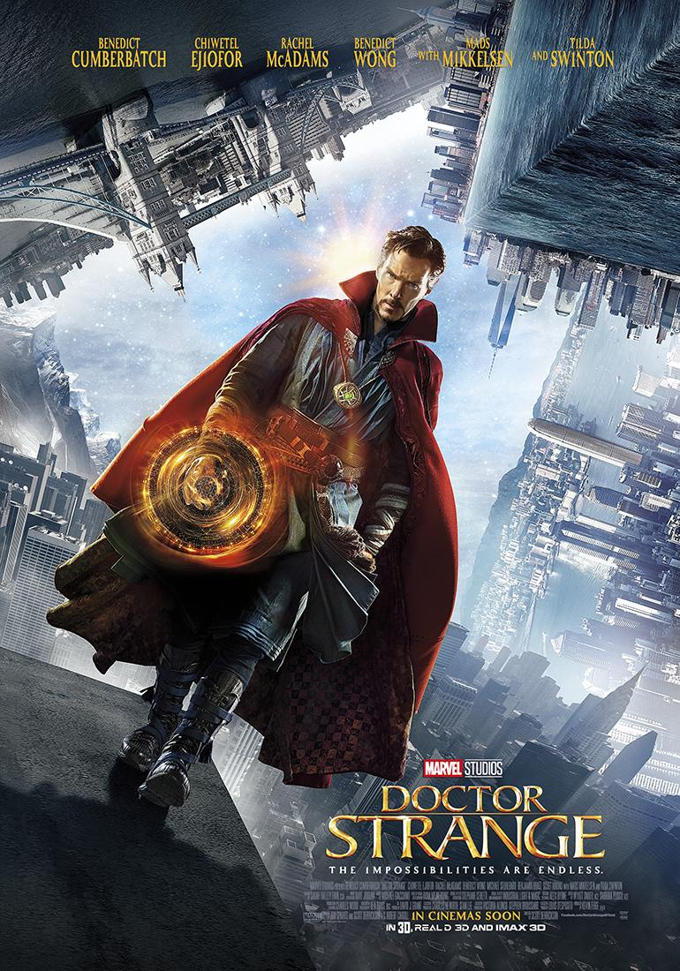
POSTER &REVIEW OF ‘DOCTOR STRANGE’ MOVIE

MOVIE REVIEW
Developmental Effects  (PR/1/DE/1-16) | This movie tells us about Stephen Strange (Strange), a doctor who is so aggressive and always has his own way to do all things. He wasted his life just for fun since he become rich. Until there’s a moment when he got the accident that might change his whole life. He can’t move his both hands which are important for him. He tried many things like surgeries until he thought about the billion-cost of cells-reproducing that still being an amateur experiment.  He then desperated and finally know that there’s a therapy in Kathmandu, Nepal. The place is called Senctrum. Long stories, he met a mysterious ‘guru’, the Ancient One, who has changed his mind about all the impossible that “logic only limits you to use your mind. Let your mind and spirit gain deeper, then change you and heal your own body”. As he learnt with her, he found his spirits deeper into powers for self-defense. One day, he was being involved in such evidence where he has to save the earth from someone who tried to destroy Senctrum, include the earth into the darkness.
Cultural Effects  (PR/1/CE/1-12) | This film was directed and set in a 21st century era. The setting that has been taken was at New York City, Nepal, London, Hong Kong, and Everest Mountain. It shows the differences of main-cultural backgrounds between New York City with its post-modern and Kathmandu, Nepal, with its oriented-spiritual culture.  The plot has shown for the first time about the evidence at Senctrum at Kathmandu, Nepal that brings a ‘teleportation scenes’ to New York City as the second location. A short duration taken in London and the climax scenes shows Hong Kong as the last location that taken. In addition, there’s a scene where Strange has been left by the Ancient One on the visual setting of Everest Mt, Nepal.
Visual Preferences  (PR/1/VP/1-16) | The visuals of setting are impressively in high-quality arrangement and it is imaginary which is interested for the adults even intermediate learners. The visuals also realistic yet there’s such modification about how the visual graphic like movements, rewind, and slow/fast-motions, are designed. Mostly used colorful contrast mode, yet there are differences between the aura of each characters in the movie. It is like the Kathmandu setting with its oriental old naturalistic contrast that differs to New York City setting with its strong futuristic contrast.  The visuals are worth in the content of the movie. Specifically, lots of medical tools and the rooms in some scenes visually can be predicted as the location was at the hospital by audience. Last but least, the visuals somehow got the researcher to conclude by herself about its message that “Do not always use your logic, use your mind and spirit to know who you really are and the way on how to face the world”.

PUBLIC
“Its latest, the giddily enjoyable “Doctor Strange,” is part of Marvel’s strategy for world domination, yet it’s also so visually transfixing, so beautiful and nimble that you may even briefly forget the brand.” –Dargis, The New York Times, 2016 –

“For a long while “Doctor Strange” works both sides of the spiritual street with spectacular success. Then the film becomes what it was sending up so delightfully.”
–Wall Street Journal, 2016 –

“Great effects with Great performances, violent crash scene may be intense for young kids.”– Jarrell B., in Common Sense Media, 2016 –

The New York Times, 2016.https://www.nytimes.com/2016/11/04/movies/doctor-strange-review.html?referrer=google_kp
Wall Street Journal, 2016.https://www.wsj.com/articles/doctor-strange-review-hold-that-scalpel-1478199522
Common Sense Media, 2016.https://www.commonsensemedia.org/movie-reviews/doctor-strange/user-reviews

