CAN MICROLEARNING STRATEGY ASSIST STUDENTS’ ONLINE LEARNING?

Rudi Susilana*, Laksmi Dewi, Gema Rullyana, Angga Hadiapurwa, Nanda Khaerunnisa
Universitas Pendidikan Indonesia, Indonesia
*e-mail: rudi_susilana@upi.edu
Abstract: The development of information and communication technology leads to the need for learning concepts and strategies following current conditions. In the higher education system, it is essential where educators must carefully consider the learning strategies of students' learning styles and cognitive loads. This study explores how microlearning strategies are applied to online learning to mediate students' cognitive load. It applies qualitative approach by involving 45 students in the student mobility program who volunteered to participate in the research process. The data were collected through questionnaires, interviews, and document analysis of student learning outcomes. They were then validated by triangulation and analyzed by following an interactive data analysis model on applying microlearning strategies in online learning. The results showed that microlearning is an effective strategy to mediate students' cognitive load in online learning curriculum development. It can be seen from students' low intrinsic and extranous cognitive load, resulting in a germane cognitive load shown in learning outcomes that fall into the nearly excellent category.

Keywords: microlearning, cognitive load, asynchronous learning.

INTRODUCTION
The impact of information and communication technology (ICT) is becoming increasingly influential in the learning process, especially in higher education learning environments. The development of ICTs has sparked the need for new concepts and strategies to support lifelong learning. Its environments require renewal and innovative ways to relate to how we live, work properly, and learn today. It has been for ages where online learning has been considered an effective way of utilizing ICT in learning. It gradually becomes an essential component in teaching and learning activities. It continues to develop, evolving from e-mail-based learning to borderless learning particularly in higher education perspective.
Online learning is a learning program using electronic means such as computers or other electronic devices such as cell phones in various ways to provide training, education, or teaching materials Stockley (2010). It learning takes place using the internet network, often referred to as e-learning. It is just one type of distance learning, where the term distance is used for any learning that takes place across distances and not in traditional classrooms (Stem, 2019). The application of online learning has opened several advantages over conventional learning; for example, online learning provides better accessibility so that students can learn from anywhere and anytime, of course, which cannot be found in conventional learning (Borstorff & Lowe 2007). Online learning has also succeeded in requiring education providers to adapt to technological developments and understand the advantages and limitations of various online learning techniques and methods. Research on learning techniques has resulted in comparing the outcomes of different online learning patterns, namely synchronous and asynchronous (Hartsinsky, 2008).
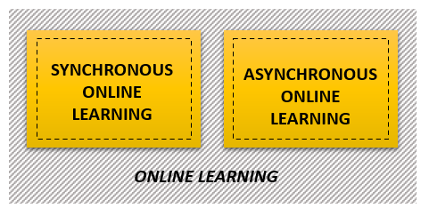
Figure 1. Online Learning Method, Hartsinsky (2008).

Synchronous and asynchronous learning is a learning pattern that is carried out in online learning. The use of online discussions, instant messaging, and others is a replication of the offline learning experience from information exchange and social construction, not only between students and teachers but also between students (Shahabadi & Uplane, 2014). Synchronous learning environments require students and teachers simultaneously to collaborate using technology (Salmon, 2013) which is similar to instructors' lectures with question and answer session facilities using the zoom application. Synchronous pattern online learning is more often referred to as virtual face-to-face. The core of synchronous stems from three main influences: the classroom, media, and conferences (Clark & ​​Kwinn 2007). Meanwhile, the asynchronous environment is not time-bound and students can do electronic activities at their own pace. Asynchronous is the pattern most widely adopted for online learning; students are not time-bound and can respond according to the allocated time (Parsad & Lewis, 2008). Asynchronous patterns are oriented towards independent and student-centered learning (Murphy, Rodríguez-Manzanares & Barbour, 2011). Therefore, asynchronous patterns can strengthen students' previous knowledge with new concepts (Lin, Hong & Lawrenz, 2012). Less reliance on memory and more opportunities for discussion with peer groups help build critical thinking and deep learning for students (Huang & Hsiao, 2012).
Asynchronous learning activities can be carried out through the Learning Management System (LMS) application to support the interaction process between educators and students. For example, like the Moodle application, this LMS provides several features filled with various multimedia learning materials, discussing in discussion forums, providing quizzes, and learning feedback. The following is a concept map for online learning activities using an asynchronous pattern.
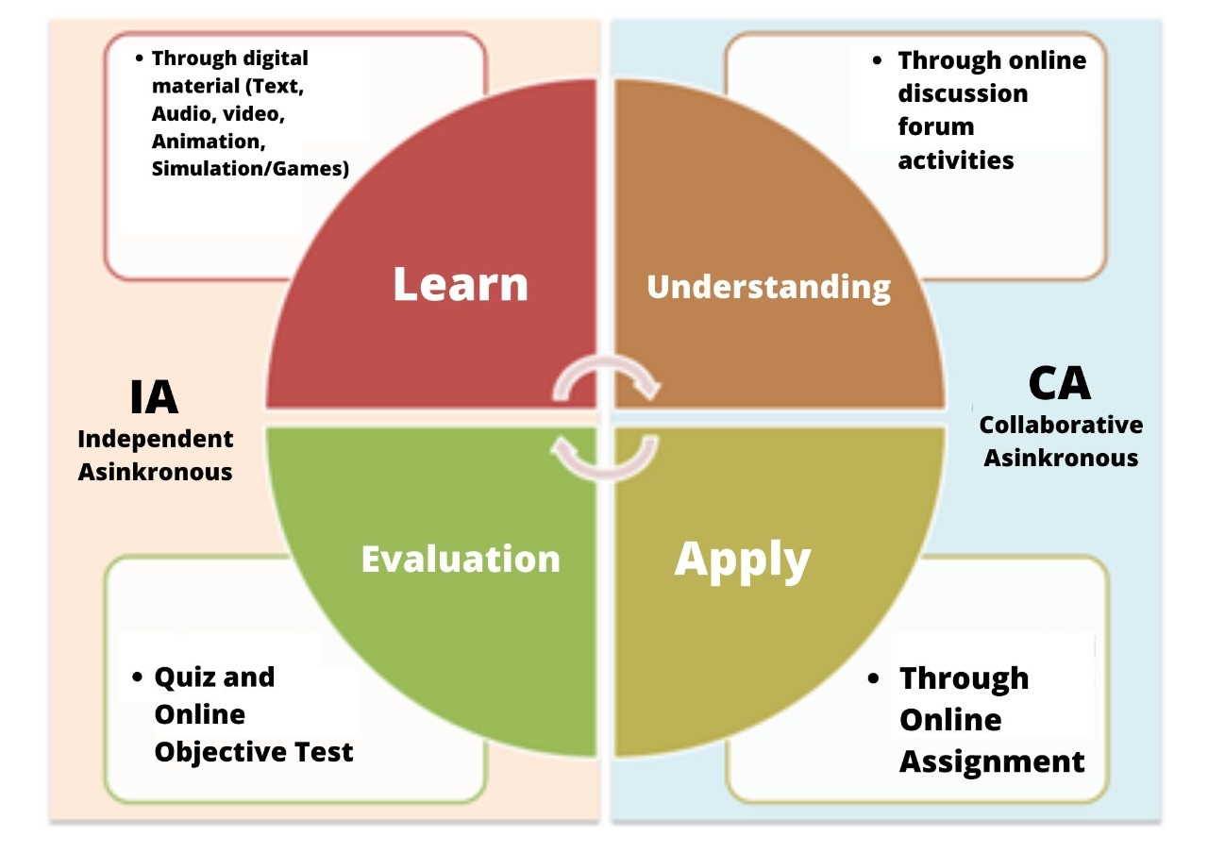
Figure 2. Online Learning Activities with Asynchronous Patterns,
Chairuman (2019)
The asynchronous learning pattern consists of 2 main parts, namely independent and collaborative asynchronous learning. Independent asynchronous consist of learning and evaluation activities, while collaborative asynchronous activities in exploration and application. Learning in independent asynchronous are reflected through some activities such as; reading through the text, paying attention through visuals, listening through audio, watching via video or animation, trying and practicing through simulations and games, and so on. Evaluation on independent asynchronous such as doing assessments in the test form objective tests such as multiple-choice, true/false, matching, short answers, and others. Dive into collaborative asynchronous, such as deepening what has been learned by actively participating in online discussion forums. This online discussion forum is also a form of assessment in asynchronous learning. Apply it to collaborative asynchronous, such as applying what has been learned by doing a given online assignment. Similar to discussion forums, online assignments are a form of assessment in asynchronous learning.
One of the challenges for universities in the current era is effectively transitioning some offline classes to online classes (Choi and Kim, 2015). The benefits of online courses are more expansive, more massive access, schedule flexibility, and lower costs, also encourage the creation of more online content for students (Akyol & Garrison, 2011). Several studies have shown that some students will learn more when compared to learning offline (Hoyek et al., 2014; Lange & Costley, 2019). But online learning is also inseparable from its shortcomings. According to (Broadbent and Poon, 2015). explains that there are at least two factors that can reduce the benefits of online learning. The first is that online learning is often autonomous, which can pressure students to motivate and organize their learning. The second is that some aspects of online learning can potentially be taxing on students' cognitive. Often the content on online learning makes students confused about understanding it. It causes a significant cognitive load on students, which results in poor performance of students in learning (Lange, 2018). Cognitive load theory is based on limited working memory capacity and extensive long-term memory (Baddeley, 2003; Hollender et al., 2010). In the context of online learning, learning must be designed so that students can maximize their learning through interaction with exciting and relevant learning content and can reduce knowledge load. Effective teaching and learning understanding revolves around looking into the number of information students are asked to process and how that information is presented (Cierniaket et al., 2009).
For the balanced knowledge load to be accepted by students, the content in online learning materials needs to be appropriately developed—the complexity of the content delivered with the capacity of students to receive the material. The material presented is less varied and will confuse students (Carpennter, Witherby & Tauber, 2020), not remembering what they have learned. For that, we need innovation in preparing teaching materials to support online learning. Microlearning is an alternative teaching material that can be developed to help the success of online learning (Conway et al., 2005; Hug, Lindner, & Bruck, 2006). In recent years microlearning has been primarily associated with online learning (Conway et al., 2005). It is one of the foundations for microlearning as an innovative approach to online learning.
According to (Abel, Moulin & Lenne, 2006), microlearning is a new concept that relates to the needs of students to learn. Besides that, microlearning also allows minimizing student difficulties in accessing correct information. The microlearning community claims that people learn better, more effectively, and more fun when information is broken down into smaller, interesting units and when learning takes small steps. Microlearning is identical to 3M, including microcontent, micro media, and micro knowledge. These three components make up microlearning and the uniqueness of this model (Hug, Lindner, & Bruck, 2006; Lindner & Bruck, 2007).
Microlearning, like other technology-mediated approaches to learning, has its advantages and disadvantages. On the one hand, microlearning has repeatedly been reinforced as an effective learning strategy because learning with small segments (microcontent, micro media, and micro knowledge) is considered more suitable for online learning (Bruck, Motiwalla, & Foerster, 2012). Microlearning is also considered to avoid excessive information with no sizeable cognitive load (Deckerd et al., 2017). Microlearning is also highlighted as having the potential to empower independent lifelong learning (Buchem & Hamelmann, 2010) and support the development of student autonomy in learning (Nikou & Economides, 2018).
There are three theories related to microlearning, including “Cognitive Load Theory” (CLT), “Cognitive Theory of Multimedia Learning” (CTML), and “Self-Determination Theory” (SDT) (Khong & Kabilan, 2020).
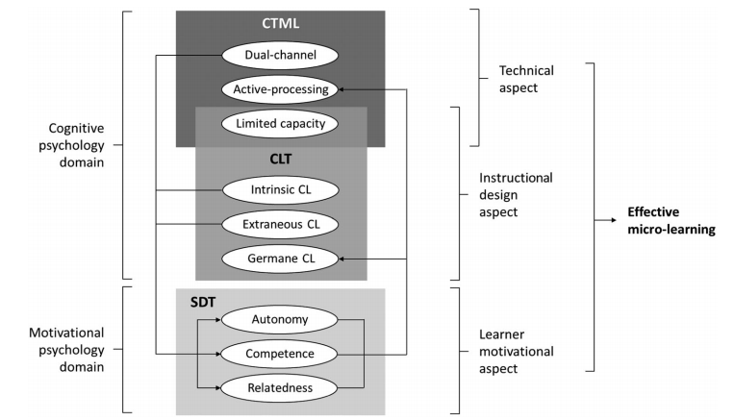
Figure 1.Theoretical and structural model of ML, Khong & Kabilan, 2020

Table 2. Concepts of CLT, CTML, and SDT in Microlearning Implementation
Theory | Concept | Implementation of Microlearning
Cognitive Load Theory” (CLT), | Is the amount of information that can be stored by memory at one time | Reducing the cognitive load by designing learning content that is divided into relatively short segments
Cognitive Theory of Multimedia Learning” (CTML) | The use of technology in microlearning leads to the concept of "multimedia learning." | The material is prepared in a multimedia format such as an explanatory video in a short duration (3-5 minutes)
“Self-Determination Theory” (SDT) | Motivation determines the "direction, intensity and persistence of behavior" of learners (Schnotz et al., 2009, p. 70). | Encourage students to be independently involved in learning.

One of the focuses of microlearning is to mediate the cognitive load theory of students through designing content into small segments (microcontent) by using various technological capabilities, especially multimedia (Khong & Kabilan, 2020). Meanwhile, cognitive load theory is centered on designing a digital micro-content architecture. Content is prepared by paying attention to cognitive load to reduce the complexity of learning material. According to Merriënboer and Sweller (2010), the focus of cognitive load theory is the ease of processing information in working memory. Next, they explained that the activity load includes three things: intrinsic cognitive load, extraneous cognitive load, and germane cognitive load. Intrinsic cognitive load is difficulty understanding learning material. One of the reasons for this can be due to not understanding the previous material. Extraneous cognitive load is the burden caused by the way the material is presented.
Meanwhile, germane cognitive load is an element that helps information processing and contributes to scheme development (Merriënboer & Sweller, 2010; de Jong, 2010). Working memory is influenced by the intrinsic nature of learning material (intrinsic load), by how learning material is presented (extraneous load), and by learning that occurs (tight load) when dealing with intrinsic load, related to students' understanding of the material given. Teacher, based on the explanation of these two theories, microlearning offers solutions to two main problems about online learning: the complexity of information and the time and place of learning (Lenne et al. 2008). Therefore, this study was conducted to determine how the microlearning strategy can mediate the cognitive load of students, which includes the intrinsic cognitive load of students, extraneous students' cognitive load, and how microlearning strategies can germanely mediate students' cognitive load online learning curriculum development courses.

METHOD
This study uses a qualitative approach and aims to explore the effectiveness of microlearning as a mode of asynchronous learning in online learning. Researchers developed a questionnaire related to research questions into two types, namely closed and open. The assessment used a Likert scale ranging from 1 strongly disagree to 5 strongly agree for closed questionnaires. The open questionnaire was a question about students' responses to microlearning strategies on students' cognitive load. The instrument contains three things: microlearning to reduce intrinsic cognitive load, mental cognitive load, and germane cognitive load. This questionnaire was used to categorize student responses. The collected data were analyzed by following an interactive data analysis model (Miles, Huberman, & Saldana, 2014) with four fundamental stages: data collection, condensation, data presentation, and conclusion drawing and verification. Data collection was carried out in early October 2020. The data for this study were obtained from 171 students from various universities who participated in the student mobility program in curriculum development courses in the educational technology study program. Among these students, 45 students were selected purposively (Creswell, 2003) to provide feedback on the effectiveness of the microlearning method as an asynchronous mode of online learning.
Online learning is designed for 16 meetings, including nine online synchronous activities and 14 online asynchronous activities. During the lecture, students should obey the rules that have been agreed upon and set including; students are required to attend synchronous online lectures at least seven meetings, students are also required to participate in online asynchronous activities at least 75% of all synchronous activities such as completing independent and group assignments, activities discussions, quizzes, and formative tests. It is a condition for student participation in taking the final exam.
It was conducted in the curriculum development course. It provides knowledge about curriculum development both theoretically and practically. The scope of this course consists of two broad outlines, namely aspects and procedures in curriculum development. Aspects of curriculum development include curriculum concepts and theories, curriculum development foundations and principles, curriculum development components, curriculum development models, curriculum development in Indonesia, and curriculum renewal. Curriculum development procedures include curriculum needs analysis, curriculum design, curriculum socialization, curriculum implementation, curriculum monitoring and control, and curriculum evaluation and improvement.

RESULT AND DISCUSSION
Result
In general, online learning is very different from conventional learning. Online learning emphasizes students' thoroughness and foresight in receiving and processing the information presented online. Therefore, giving material in online pursuits is a challenge that must be a concern, how to design online learning by offering sound, engaging, and easy to understand for students in cognitive load factors that can shift students' focus while learning. In online learning, cognitive load can include three things, namely intrinsic cognitive load, extraneous or germane. Cognitive load relates the limited nature of students' working memory to learning. Therefore it is vital to design learning that explicitly does not exceed the cognitive load (working memory) so that meaningful learning occurs. Based on this, the Microlearning strategy can be used as a strategy for designing learning designs, one of which is designing content into small and focused segments. The content in question is in the form of learning objects used in online learning. This section then presents empirical findings regarding microlearning as an online learning strategy to mediate student cognitive load problems.

Microlearning strategy on students' intrinsic cognitive load
Ideally, microlearning can help reduce students' cognitive load when studying learning material because microlearning is developed in small ways in the form of learning objects with various media formats. This strategy hopes that their cognitive load on the intrinsic cognitive load aspect will be reduced. Because understanding the material becomes more accessible because the material is delivered step by step.
Learning objects designed with microlearning strategy pay attention to several principles to mediate the students' intrinsic cognitive load; these principles include the principles of segmenting, pretraining, and modality (Mayer & Moreno, 2010). So that the indications of the learning object being developed have 1) the topic of the material discussed in each media is clear and simple, 2) an explanation of the learning objectives is available on each content; 3) content is delivered in a relatively small segment, 4) content delivered in each format has a relationship with each other, 5) various media formats developed, 6) developed media displays content adapted to the developed media format.
Based on the following questionnaire data, the mean and standard deviation of cognitive intrinsic load are presented.
The following is a presentation of the questionnaire results, which have been categorized as interpreted/interpreted.
Table 1. Distribution of Respondents Intrinsic Cognitive Load Level
Type of Cognitive Load | Average Value | Standard Deviation Value
Intrinsic Cognitive Load | 4.39 | 0.153

Student responses to the overall level of intrinsic cognitive load obtained an average value of 4.39 with a standard deviation of 0.153. Based on the questionnaire results, it can be inferred that most students have positive perceptions and agree to the use of microlearning strategies in online learning. The positive perceptions of these students indicate that the microlearning strategy has an excellent opportunity to mediate the intrinsic cognitive load of students in online learning.
The students further argued that the microlearning strategy resulted in content that was easy to understand. Most of the students stated that the content arranged in relatively small segments was easier to understand. They also claimed that the content with relatively small components was suitable for their learning style. Students are also pleased with the content available in various formats, such as audio, visual, audio-visual, and multimedia formats. The research results also show that narration and illustrations in multimedia format can make it easier for students to understand the material. Through online asynchronous activities, students have independently stimulated themselves to carry out learning activities alone or in groups to achieve specific competencies through content designed using a microlearning strategy. While the results of interviews with students can be concluded that they appreciate and like the content compiled using the microlearning strategy, according to their experience, the content can be accessed according to their learning readiness, can be repeated, and can be easily controlled so that they feel they do not get too much cognitive load—primarily during online lectures. In short, it is known that microlearning as an online learning strategy has been empirically proven to reduce students' intrinsic cognitive load.

Microlearning strategy against extraneous cognitive load
Extraneous cognitive load in the learning process can be minimized through how learning is displayed. Lack of explanation in instruction will place a high burden on memory when learning because memory is used more to pay attention to instructions than to understand the material's content being conveyed. It, of course, needs to be minimized; providing clear and concise learning instructions will offer opportunities for memory to understand learning content for longer.
Learning objects designed with microlearning strategy focus on several principles to mediate extraneous student cognitive loads; these principles include the principles of coherence, redundancy, signaling, temporal contiguity, spatial and contiguity (Mayer & Moreno, 2010). Based on these principles, the designed learning object has indications including 1) displaying words and images that are relevant and easy to understand, 2) for microlearning with a format there is a sound that is provided with background music that can help concentrate on learning, 3) delivery techniques in video and audio media adjusted to the characteristics of students, 4) illustrations presented in microlearning can help connect a concept, 5) use of appropriate fonts, 6) collaboration of various colors to arouse learning motivation, 7) collaboration of writing and images displayed makes it easier for students to understand and 8) the layout of the text and images is displayed in a balanced manner.
The following is a presentation of the results of calculating the average and standard deviation of the questionnaire data that has been obtained:

Table 2. Distribution of Respondents on the Level of Extraneous Cognitive Load
Type of Cognitive Load | Average Value | Standard Deviation Value
Extraneous Cognitive Load | 4.24 | 0.104

Student responses to the level of extraneous cognitive load of students obtained an average value of 4.25 with a standard deviation of 0.104. Based on the questionnaire results, it can be concluded that most students have positive perceptions and agree that the use of microlearning strategies in online learning can reduce their extraneous cognitive load.
Extraneous cognitive load is a cognitive load that must be minimized in the learning process. This cognitive load appears on students when the learning process takes place. In the context of asynchronous online learning, students' extraneous cognitive load is carried by students such as technical factors in the presentation of the material used in learning, quality of images or illustrations on the media, quality of audio narratives, quality of audio fonts, colors, and media layout. These have the potential to become external distractions during learning. It takes place and brings the potential to impart an extraneous cognitive load on students.
The students further argued that the content accessed had good quality images and text, was simple, relevant, and mutually constructive. It immensely helped students understand the material in it. Most of the students stated that the content equipped with narration in audio helped them understand the material more easily. They assessed the narrator's style in conveying according to their characteristics, namely a clear voice and a non-monotonous style of delivery. They also claim that visual factors such as fonts, images, and layout styles help their attention and construction. Based on the results of the interviews, students stated that the content developed with a microlearning strategy was more interesting and by their character. They claim that monotonous and uninteresting content distracts their attention while studying, unlike content packaged in online lessons in curriculum development courses. Students appreciate the available content in various formats, such as audio, visual, audio-visual, and multimedia formats. Based on these findings, it is known that microlearning as an online learning strategy has been empirically proven to reduce the cognitive load of extranous students.

Microlearning strategy on students' Germane cognitive load
Asynchronous online learning activities in the curriculum development course consist of independent and collaborative asynchronous. Students independently learn the materials provided in various formats, such as explanatory videos, audio published on podcasts, infographics, and other media in independent asynchronous activities. The learning material in the explainer video format is presented in several segments so that students can more easily learn the material presented.
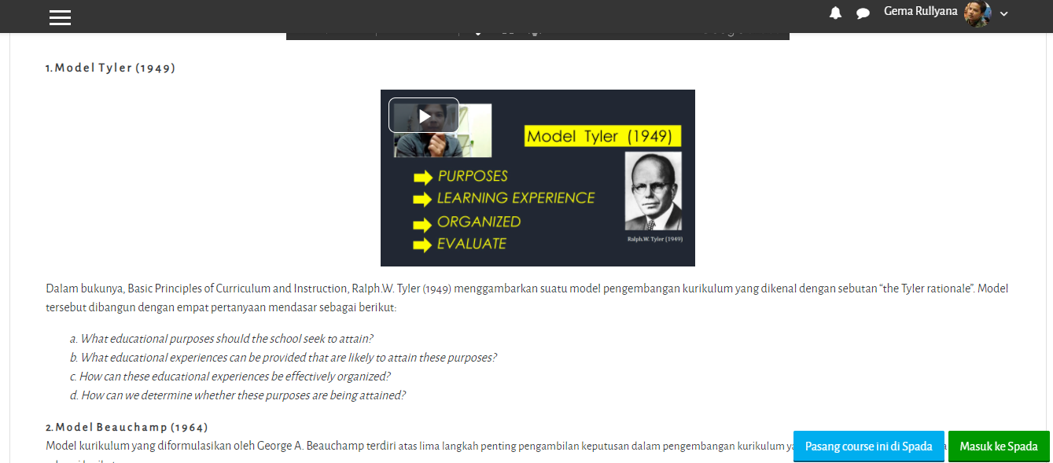
Figure 3. Independent Material Learning Activities (Independent Asynchronous)

In addition, another independent activity carried out by students is evaluation. Each part of the asynchronous meeting is equipped with a formative self-evaluation format available on the Moodle LMS application. Students can independently measure the extent of their understanding of the topic.
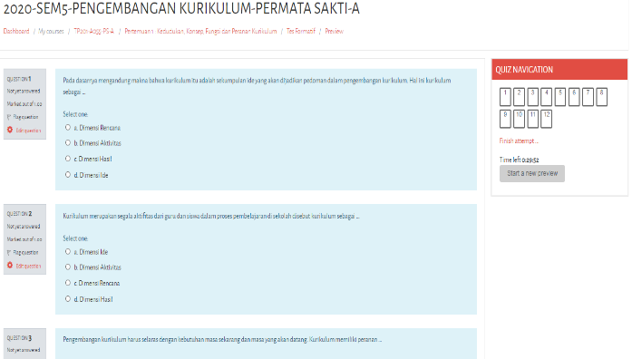
Figure 4. Self-Evaluation Activities (Asynchronous Mandiri)
In collaborative asynchronous activities, students also actively participate in every action that has been designed, for example, as exploring material through online discussion activities available on the Moodle application.
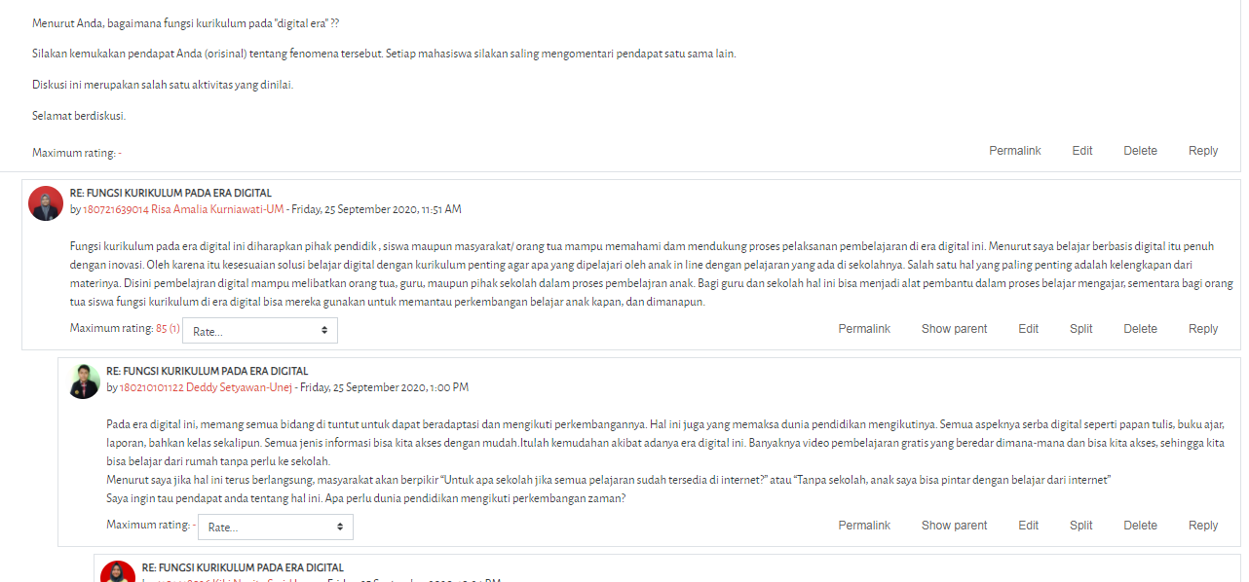

Figure 5. Collaborative Discussion Activities (Collaborative Asynchronous)
In addition, to join collaborative online discussion activities, students are also actively completing collaborative assignments available on the Moodle application. Brands communicate virtually to complete collaborative tasks; they take advantage of the WhatsApp channel and the gmeet app to discuss conveying problem-solving ideas and crafting products.
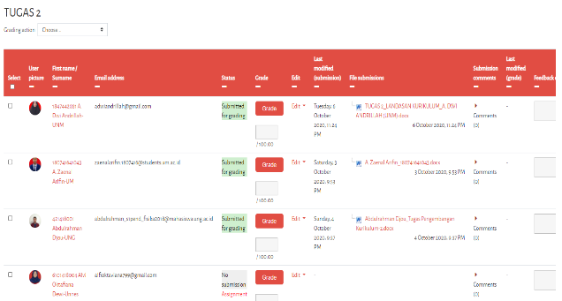
Figure 6. Collaborative Task Activities (Asynchronous Collaborative)
This activity certainly impacts the final cognitive load component, namely the germane cognitive load; the germane cognitive load of students is traced from the value of learning outcomes taken after they take online learning in curriculum development courses. Cognitive load is an effective load because the load generated is a burden to form cognitive schemes such as making knowledge structures and relating to the knowledge already possessed by students. The following are the results of learning outcomes scores in online development classes classified as nearly excellent categories.

Table 3. Categories and Student Learning Outcomes
Letter | Number | Degree of Quality | Total
A | 4 | Excellent | 23
A- | 3.7 | Nearly Excellent | 15
B+ | 3.4 | Very Good | 7
B | 3 | Good | 0
B- | 2.7 | Good Enough | 0
C+ | 2.4 | Fair Enough | 0
C | 2 | Enough | 0
D | 1 | Bad | 0
E | 0.9 | Failed | 0

Based on the evaluation results, 23 students got a special quality degree or 51.11%, who became the highest. Furthermore, with a nearly excellent degree of quality, there were 15 people or 33.33%. There are seven people, or 15.56%, with very good degrees of quality, which is the minimum score for students. Overall, the average score obtained by students on learning outcomes was 3.7 or included in the nearly excellent category. It shows that the microlearning strategy in online learning in curriculum development courses can reduce students' germane cognitive load.

Discussion
This study emphasizes the exploration of three different roles of microlearning as an online learning strategy, namely how microlearning strategies can mediate students' intrinsic cognitive load, how microlearning strategies can mediate students' extraneous cognitive load, and how microlearning strategies can mediate students' germane cognitive load on online eye learning—curriculum development courses. Microlearning, in particular, can be used to design online learning activities that are more meaningful for students, provide content that is easy for students to learn without space and time constraints, and carry out learning activities anytime and anywhere, either independently or collaboratively.

Microlearning strategy on students' intrinsic cognitive load
In general, students have positive perceptions and agree that using microlearning strategies in online learning can mediate their intrinsic cognitive load. They believe that the use of microlearning strategies has facilitated more meaningful online learning activities so that learning objectives are easier to achieve. Following this positive perception, intrinsic cognitive load can be mediated by providing micro-content and macro media to generate micro-knowledge. These three things are characteristic of microlearning (Hug, Lindner, & Bruck, 2006; Lindner & Bruck, 2007). It means that the microlearning strategy allows students to learn more effectively during online learning. Students are well encouraged to overcome learning difficulties independently or in groups without guidance from the teacher. Intrinsic cognitive overload occurs when the material is complex or is presented in a long and lengthy manner. Intrinsic cognitive load depends on the level of difficulty of the material. However, designing content with good techniques that do not complicate students' understanding will manage the intrinsic cognitive load (Mayer & Moreno, 2010). With microlearning, learning content with a long enough duration is presented into short videos with a duration of 1-3 minutes and can even be used as a single sheet infographic. It is done to reduce students' cognitive overload so that the content is easy to absorb and remember. Presentation with a microlearning strategy produces a short, practical range and can be accessed anytime and anywhere when needed.
According to Miller, working memory can hold no more than seven elements of information for about 20 seconds at a time. Therefore, the limited nature of working memory with learning materials must not exceed the cognitive load so that meaningful learning can occur (Leppink & Hanham, 2019; Paas, Ayres, & Pachman, 2008). The concept of content and micro media can convey some knowledge and information in a structured, well-defined, and interconnected manner. This concept is suitable for online learning by using various types of online learning modes, such as Moodle, Edmodo, and so on; even the content is easily accessible on smartphone devices so that learning activities can occur anywhere and anytime (Giurgiu 2017). Moodle as an online learning mode in curriculum development courses can be applied to overcome the limitations of online learning. As a learning model, many students think that when online teaching is based on microlearning with Moodle mode, the instruction becomes much more interesting and compelling. Therefore, Sweller, Kirschne & Clark (2007) explained in their research that instructional design using well-planned microlearning intends to reduce cognitive load. By creating concise and organized content, students can maximize their working memory capacity. Chan (2002) states that information technology-based learning can increase instruction efficiency, effectiveness, and productivity. The reason is that the learning practice takes place inside the classroom and outside the classroom; students and teachers can virtually interact and have discussions outside the classroom (Ali, 2015; Mokhtar, 2016).

Microlearning strategy against extraneous cognitive load
In the aspect of extraneous cognitive load, students generally have positive perceptions and agree that using microlearning strategies in online learning can mediate their extraneous cognitive load. In the context of microlearning, minimizing the extraneous cognitive load in online learning is one of the ways to pay attention to the principles of developing micro media as a channel for micro-content to students. The extraneous cognitive load depends on how the material to be studied is presented. Good material processing can reduce the extraneous cognitive load, and vice versa if the presentation of the material is not appropriately packaged, cognitive processing is irrelevant and efficient (Mayer, 2009). According to Mayer & Moreno (2010), the purpose of designing micro media in online learning is to reduce extraneous cognitive load processing, regulate intrinsic cognitive load processing, and help develop fast cognitive load processing.
Many students think that interesting and relevant images and texts make it easier for them to understand the content during online learning. Therefore, Mayer & Moreno (2010) emphasize that learning can be disrupted if words and pictures are not attractive and less relevant to the material contained in the micro media. Furthermore, he explained that students would learn better when unnecessary and irrelevant words, pictures, sounds, videos, or animations are not used. Students learn better when words, images, or sounds don't need to be thrown away. Theoretically, elements that do not need to compete to take advantage of cognitive resources in working memory and can distract from important material, as a result, will interfere with the process of organizing the material, students' working memory will work heavier and more complex. According to Schnotz et al. (2007), the way the presentation of formations affects students' attention, students' attention will be divided according to it. It will be better when students are presented with visual sources only but can be collaborated with more varied information sources, such as narration in audio form.
Furthermore, according to Hoffman (2006), eliminating redundant material, avoiding "identical" narratives and texts would be an excellent way to make students learn well. The fundamental reason is that people can't focus when they both hear and see the same verbal message. The principle of redundancy in media development states that students can learn better through animation with narration. Clark and Mayer (2016) describe several potential problems, students may be attracted by large-displayed words and may pay less attention to the accompanying pictures. Furthermore, he also argued, students may experience cognitive overload in visual media, having excessive text on the screen.
Mayer (2014) argues that students will learn from text and images rather than from text alone. This statement is also the principle underlying the development of micro-content on microlearning, namely the multimedia principle, which explains how people actively try to build meaningful connections by selecting relevant words and images (static or dynamic) through auditory and visual channels in working memory. The chosen words become mental models of verbal while the selected images become mental models with pictures, and finally integrate the two mental models with existing knowledge from long-term memory into a coherent mental representation (Mayer & Moreno 2010). Therefore, it is logical to conclude that microcontent using multimedia principles through technology will enable students to effectively utilize working memory capacity (Mayer, 2014; Schnotz et al., 2009).
Current technological developments also allow various ways to creatively present content, for example, on curriculum concept material, using 60-second video explainers, on curriculum procedure material using 30-second animation; this is based on research findings proving students prefer packaged information a duration that is not long. Microlearning provides students with a variety of alternative micro media. According to the students, the research results show that they appreciate the variety of micro media because it is under their learning style. It means that students are allowed to try to compare different formats. Microlearning is also consistent with the concept of memory capacity; during learning activities, students are given repeated opportunities to actively process (select, organize, integrate) micro-content to encourage meaningful learning (Mayer, 2017; Sorden, 2012).

Microlearning strategy on students' Germane cognitive load
The last component of cognitive load is Germane cognitive load. Cognitive load is germanely traced from the value of student learning outcomes taken after online learning curriculum courses and learning ends. Cognitive load can germanely be assumed to be cognitive load caused by cognitive processes relevant to understanding the material being studied or the process of knowledge construction (Mayer, 2017). If there is no tight cognitive load, it means that students' working memory cannot organize, construct, elaborate or integrate the material being studied as the knowledge that is appropriately stored in students' long-term memory. Extraneous cognitive load is assumed as a category of the reduced cognitive load so that the cognitive load will automatically increase because learners will devote the same effort to learning. Cognitive load is also called an effective load because the load generated is a burden to form cognitive schemes such as creating knowledge structures and linking with the knowledge already possessed by students (Brünken et al., 2010). The learning design must reduce extraneous burdens and be more effective by increasing the load tightly, but provided that the total cognitive load remains within limits and does not overload students' working memory.
According to the data, the mean value of learning outcomes is in a nearly excellent category. Even though it is in the nearly special category, the achievements obtained have not reached the highest category, so that it can be said that the student still has a cognitive load but a low cognitive load. It shows that the microlearning strategy is empirically proven to reduce students' tight cognitive load. The microlearning strategy is based on psychological research, which recommends that learning can be improved by grouping content into smaller segments so that learning is easy to remember so that meaningful learning occurs (Fountain & Doyle, 2012). Furthermore, suppose it is correlated with cognitive load theory. In that case, it states that each student has limitations on memory performance, so breaking learning content into short and concise segments can potentially help with memory coding (Kirschner, 2002). There is evidence that students studying in an online learning environment prefer content designed according to the principles of microlearning (Javorcik & Polasek, 2018). Based on the research findings, the microlearning content delivered uses effective technology capabilities to improve student learning outcomes, engagement, overall learning experience and save their cognitive load.

CONCLUSION
Based on the research findings, it can be concluded that microlearning as an online learning strategy tends to mediate the cognitive load of students, including intrinsic, extraneous, and germane cognitive loads, because the microlearning strategy in online learning makes it easier for students to understand the material. It is also more flexible in learning because the microlearning strategy allows students to determine their learning readiness. Cognitive load relates the limited nature of students' working memory to learning. Therefore the microlearning strategy allows online learning that does not explicitly exceed the cognitive load (working memory) to obtain meaningful learning. Based on this, microlearning can be used as a strategy in designing online learning.
There are several implications from the results of this study. First, teachers may need to reflectively on how they teach to improve online learning practices, particularly on asynchronous patterns. Second, if the teacher correctly assumes that content is an essential component of online learning, the teacher must consider the ability and readiness to design learning object materials. This study emphasizes exploring the effectiveness of microlearning strategies applied to online learning to mediate students' cognitive load. Therefore, it is necessary to dig deeper whether the preferences and attitudes of students towards microlearning as a learning strategy can increase motivation to learn independently and impact learning achievement.

ACKNOWLEDGEMENT
The authors received grants from the Indonesian Ministry of Research and Technology/ National Agency for Research and Innovation.

REFERENCES
- Abel, M. H., Moulin, C., & Lenne, D. (2006). Learning organizational memory and microlearning (semantics for microlearning). Retrieved from: https://www.researchgate.net/profile/Marie-Helene-Abel/publication/239752343_Learning_Organizational_Memory_and_Microlearning_Semantics_for_Microlearning/links/550066b30cf2aee14b547815/Learning-Organizational-Memory-and-Microlearning-Semantics-for-Microlearning.pdf
- Akyol, Z., & Garrison, D. R. (2011). Understanding cognitive presence in an online and blended community of inquiry: Assessing outcomes and processes for deep approaches to learning. British Journal of Educational Technology, 42(2), 233-250. https://doi.org/10.1111/j.1467-8535.2009.01029.x
- Ali, Z. (2015). A case study of tertiary students" experiences using Edmodo in language learning. International Journal of Language Education and Applied Linguistics, 02(2015), 39-48. https://doi.org/10.15282/ijleal.v2.462
- Baddeley, A. (2003). Working memory and language: an overview. Journal of Communication Disorders. 36(2003) 189 – 208. https://doi.org/10.1016/S0021-9924(03)00019-4
- Borstorff, P. C., & Lowe, S. L. (2007).Student perceptions and opinions toward e-learning in the college environment. Academy of Educational Leadership Journal, 11(2), 13–30.
- Broadbent, J., & Poon, W. L. (2015). Self-regulated learning strategies & academic achievement in online higher education learning environments: A systematic review. The Internet and Higher Education, 27, 1-13. https://doi.org/10.1016/j.iheduc.2015.04.007
- Bruck, P. A., Motiwalla, L., & Foerster, F. (2012). Mobile Learning with Micro-content: A Framework and Evaluation. Bled eConference, 25, 527-543.
- Buchem, I., & Hamelmann, H. (2010). Microlearning: a strategy for ongoing professional development. eLearning Papers, 21(7), 1-15.
- Carpenter, S. K., Witherby, A. E., & Tauber, S. K. (2020). On students' (mis) judgments of learning and teaching effectiveness. Journal of Applied Research in Memory and cognition, 9(2), 137-151. https://doi.org/10.1016/j.jarmac.2019.12.009
- Chaeruman, U. A. (2019). Merancang Model Blended Learning Designing Blended Learning Model. Jurnal Teknodik, 17(4), 053-063. http://dx.doi.org/10.32550/teknodik.v17i4.577
- Chan, F. M. (2002). ICT in Malaysian schools: Policy and strategies. Retrieved from: http://www.share4dev.info/kb/documents/3513.pdf
- Clark, R. C., & Kwinn, A. (2007). The new virtual classroom: Evidence-based guidelines for synchronous e-learning. New Jersey: John Wiley & Sons.
- Clark, R. C., & Mayer, R. E. (2016). E-learning and the science of instruction: Proven guidelines for consumers and designers of multimedia learning. New Jersey: John Wiley & sons.
- Conway, A. R., Kane, M. J., Bunting, M. F., Hambrick, D. Z., Wilhelm, O., & Engle, R. W. (2005). Working memory span tasks: A methodological review and user’s guide. Psychonomic bulletin & review, 12(5), 769-786. https://doi.org/10.3758/BF03196772,
- Creswell, J. W. (2012). Qualitative inquiry and research design: Choosing among five approaches. (3rd ed.).Thousand Oaks: Sage Publications.
- Decker, J., Hauschild, A. L., Meinecke, N., Redler, M., & Schumann, M. (2017, October). Adoption of micro and mobile learning in German enterprises: A quantitative study. In European Conference on e-Learning (pp. 132-141). Academic Conferences International Limited.
- De Jong, T. (2010). Cognitive load theory, educational research, and instructional design: some food for thought. Instructional Science, 38(2), 105-134. https://doi.org/10.1007/s11251-009-9110-0
- Giurgiu, L. (2017). Microlearning an evolving e-learning trend. Scientific Bulletin-Nicolae Balcescu Land Forces Academy, 22(1), 18-23. https://doi.org/10.1515/bsaft-2017-0003
- Huang, X. & Hsiao, E. L. (2012). Synchronous and asynchronous communication in an online environment: Faculty experiences and perceptions. Quarterly Review of Distance Education, 13(1), 15–30
- Hollender, N., et al. (2010). Integrating cognitive load theory and concepts of human-computer interaction. Journal Computer in Human Behavior. 26(2010), 1278–1288. https://doi.org/10.1016/j.chb.2010.05.031.
- Hoyek, N., Collet, C., Di Rienzo, F., De Almeida, M., & Guillot, A. (2014). Effectiveness of three‐dimensional digital animation in teaching human anatomy in an authentic classroom context. Anatomical sciences education, 7(6), 430-437. https://doi.org/10.1002/ase.1446
- Hrastinski, S. (2008). Asynchronous and synchronous e-learning. Educause quarterly, 31(4), 51-55. https://doi.org/10.1111/j.1467-8535.2012.01306.x
- Hug, T., Lindner, M., & Bruck, P. A. (2006). Macromedia & e-Learning 2.0: Gaining the Big Picture: Proceedings of Microlearning Conference 2006 (p. 332). innsbruck university press.
- Khong, H. K., & Kabilan, M. K. (2020). A theoretical model of micro-learning for second language instruction. Computer Assisted Language Learning, 1-24. https://doi.org/10.1080/09588221.2020.1818786
- Klein, G., & Hoffman, R. R. (2008). Naturalistic decision-making and macrocognition. Burlington: Ashgate Publishing Limited.
- Lange, C. (2018). The relationship between system-provided learner control and maintained situational interest within e-learning courses. Interactive Technology and Smart Education, Vol. 15 No. 3, pp. 205-219. https://doi.org/10.1108/ITSE-12-2017-0062
- Lange, C., & Costley, J. (2020). Improving online video lectures: learning challenges created by media. International Journal of Educational Technology in Higher Education, 17, 1-18. https://doi.org/10.1186/s41239-020-00190-6
- Lee, Y., Choi, J., & Kim, T. (2013). Discriminating factors between completers of and dropouts from online learning courses. British Journal of Educational Technology, 44(2), 328-337. https://doi.org/10.1111/j.1467-8535.2012.01306.x
- Lenne, D., Abel, M. H., Trigano, P., & Leblanc, A. (2008). Self‐regulated learning in Technology Enhanced Learning Environments: an investigation with university students. Technology, Pedagogy, and Education, 17(3), 171-181. https://doi.org/10.1080/14759390802383751
- Leppink, J., & Hanham, J. (2019). Human cognitive architecture through the lens of cognitive load theory. In Instructional design principles for high-stakes problem-solving environments (pp. 9-23). Singapore: Springer. https://doi.org/10.1007/978-981-13-2808-4_2
- Lin, H. S., Hong, Z. R., & Lawrenz, F. (2012). Promoting and scaffolding argumentation through reflective asynchronous discussions. Computers & Education, 59(2), 378–384. http://dx.doi.org/10.1016/j.compedu.2012.01.019
- Lindner, M., & Bruck, P. A. (2007). Micromedia and corporate learning. In Proceedings of the 3rd International Microlearning 2007 Conference (Vol. 8). Innsbruck : University Press.
- Mayer, R. E. (2009). Multimedia learning (2nd ed). New York: Cambridge University Press.
- Mayer, R. E. (2014). Incorporating motivation into multimedia learning. Learning and Instruction, 29, 171-173. https://doi.org/10.1016/j.learninstruc.2013.04.003
- Mayer, R., & Moreno, R. (2010). Techniques That Reduce Extraneous Cognitive Load and Manage Intrinsic Cognitive Load during Multimedia Learning. In J. Plass, R. Moreno, & R. Brünken (Eds.), Cognitive Load Theory (pp. 131-152). Cambridge: University Press. https://doi.org/10.1017/CBO9780511844744.009
- Van Merriënboer, J. J., & Sweller, J. (2010). Cognitive load theory in health professional education: design principles and strategies. Medical education, 44(1), 85-93. https://doi.org/10.1111/j.1365-2923.2009.03498.x
- Miles, H., & Huberman, A. M. Saldana.(2014). Qualitative data analysis: A methods sourcebook, 3. New York: Sage publications.
- Mokhtar, F. A. (2016). Rethinking conventional teaching in language learning and proposing Edmodo as intervention: A qualitative analysis. Malaysian Online Journal of Educational Technology, 4(2), 22-37.
- Murphy, E., Rodríguez-Manzanares, M. A., & Barbour, M. (2011). Asynchronous and synchronous online teaching: Perspectives of Canadian high school distance education teachers. British Journal of Educational Technology, 42(4), 583–591. http://dx.doi.org/10.1111/j.1467-8535.2010.01112.x
- Nikou, S. A., & Economides, A. A. (2018). Mobile‐Based micro‐Learning and Assessment: Impact on learning performance and motivation of high school students. Journal of Computer Assisted Learning, 34(3), 269-278. https://doi.org/10.1111/jcal.12240
- Paas, F., Ayres, P., & Pachman, M. (2008). Assessment of cognitive load in multimedia learning: Theory, methods, and applications. In D. H. Robinson & G. Schraw (Eds.), Recent innovations in educational technology that facilitate student learning (pp. 11–35). Charlotte: Information Age Publishing.
- Parsad, B., Lewis, L., & Tice, P. (2008). Distance education at degree-granting postsecondary institutions: 2006-2007 (pp. 90-95). Washington, DC: National Center for Education Statistics, Institute of Education Sciences, US Department of Education.
- Salmon, G. (2013). E-activities: The key to active online learning. London: Routledge.
- Schnotz, W., Fries, S., & Horz, H. (2009). Motivational aspects of cognitive load theory. In M. Wosnitza, S. A. Karabenick, A. Efklides, & P. Nenniger (Eds.), Contemporary motivation research: From global to local perspectives (pp. 69-96). Boston: Hogrefe & Huber Publishers.
- Schnotz, W., & Kürschner, C. (2007). A reconsideration of cognitive load theory. Educational psychology review, 19(4), 469-508. http://10.1007/s10648-007-9053-4
- Shahabadi, M. M., & Uplane, M. (2014). Learning styles and academic performance of synchronous E-learning students. Asian Journal of Research in Social Sciences and Humanities, 4(5), 148-161.
- Stem, J. (2019). Introduction to online teaching and learning. Retrieved from: http://www.edu/online/documents/otl.pdf.
- Stockley, D., 2010. E-learning definition and explanation (E-learning, online training, online learning). Retrieved from: http://www.derekstockley.com.au/elearning-definition.html
- Sweller, J., Kirschner, P. A., & Clark, R. E. (2007). Why minimally guided teaching techniques do not work: A reply to commentaries. Educational psychologist, 42(2), 115-121. https://doi.org/10.1080/00461520701263426
- Brünken, R. E., Plass, J. L., & Moreno, R. E. (2010). Current issues and open questions in cognitive load research. Brunken, R., Plass, J. L., & Moreno, R. (2010). Current issues and open questions in cognitive load research. In J. L. Plass, R. Moreno, & R. Brunken (Eds.), Cognitive load theory (pp. 253e272). New York: Cambridge University Press.
- Sorden, S. D. (2012). The cognitive theory of multimedia learning. In B. J. Irby, G. Brown, R. Lara-Alecio, & S. Jackson (Eds.), The handbook of educational theories (pp. 155–167). North Carolina: Information Age Publishing.
- Fountain, S. B., & Doyle, K. E. (2012). Learning by chunking. Encyclopedia of the Sciences of Learning, (pp. 1814–1817). Boston MA: Springer. https://doi.org/10.1007/978-1-4419-1428-6_1042
- Kirschner, P. A. (2002). Cognitive load theory: Implications of cognitive load theory on the design of learning. Learn. Instr. 12(1), 1–10. https://doi.org/10.1016/S0959-4752(01)00014-7
- Javorcik, T., & Polasek, R. (2018, November). The basis for choosing microlearning within the terms of e-learning in the context of student preferences. In 2018 16th international conference on emerging eLearning technologies and applications (ICETA) (pp. 237-244). IEEE. https://10.1109/ICETA.2018.8572183

