# SUPLEMEN TAMBAHAN

# Hasil SPSS AMOS 22, Uji Hipotesis (model Fit) Goodness of Fit (GOF)

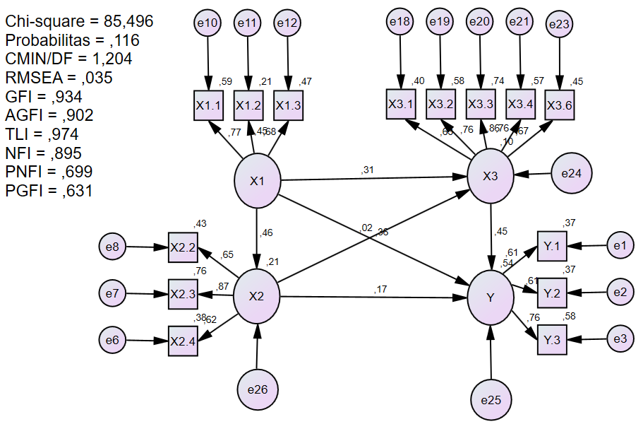

**Variable Summary (Group number 1)**

**Your model contains the following variables (Group number 1)**

Observed, endogenous variables

Y.1

Y.2

Y.3

X2.4

X2.3

X2.2

X1.1

X1.2

X1.3

X3.1

X3.2

X3.3

X3.4

X3.6

Unobserved, endogenous variables

Perkembangan.Emosi

Komunikasi.Interpersonal

Smartphone.Addiction

Unobserved, exogenous variables

e1

e2

e3

e6

e7

e8

e10

e11

Lingkungan.Keluarga

e12

e18

e19

e20

e21

e23

e24

e25

e26

**Variable counts (Group number 1)**

|  |  |
| --- | --- |
| Number of variables in your model: | 35 |
| Number of observed variables: | 14 |
| Number of unobserved variables: | 21 |
| Number of exogenous variables: | 18 |
| Number of endogenous variables: | 17 |

**Parameter Summary (Group number 1)**

|  | Weights | Covariances | Variances | Means | Intercepts | Total |
| --- | --- | --- | --- | --- | --- | --- |
| Fixed | 21 | 0 | 0 | 0 | 0 | 21 |
| Labeled | 0 | 0 | 0 | 0 | 0 | 0 |
| Unlabeled | 16 | 0 | 18 | 0 | 14 | 48 |
| Total | 37 | 0 | 18 | 0 | 14 | 69 |

**Assessment of normality (Group number 1)**

| Variable | min | max | skew | c.r. | kurtosis | c.r. |
| --- | --- | --- | --- | --- | --- | --- |
| X3.6 | 4,000 | 12,000 | ,151 | ,793 | -,256 | -,670 |
| X3.4 | 5,000 | 12,000 | -,837 | -4,391 | ,518 | 1,357 |
| X3.3 | 6,000 | 12,000 | -,449 | -2,354 | -,425 | -1,115 |
| X3.2 | 2,000 | 8,000 | -,461 | -2,417 | ,193 | ,505 |
| X3.1 | 12,000 | 20,000 | -1,109 | -5,814 | 1,128 | 2,958 |
| X1.3 | 11,000 | 20,000 | -,140 | -,736 | ,184 | ,482 |
| X1.2 | 7,000 | 14,000 | -,285 | -1,497 | -,482 | -1,265 |
| X1.1 | 11,000 | 20,000 | -,574 | -3,009 | -,127 | -,332 |
| X2.2 | 10,000 | 16,000 | ,345 | 1,812 | -,790 | -2,070 |
| X2.3 | 9,000 | 16,000 | ,598 | 3,135 | ,489 | 1,282 |
| X2.4 | 9,000 | 16,000 | ,562 | 2,946 | ,141 | ,369 |
| Y.3 | 11,000 | 24,000 | ,444 | 2,328 | ,327 | ,856 |
| Y.2 | 10,000 | 20,000 | -,159 | -,835 | -,748 | -1,961 |
| Y.1 | 8,000 | 16,000 | -,779 | -4,085 | ,433 | 1,134 |
| Multivariate |  |  |  |  | 4,430 | 1,344 |

**Observations farthest from the centroid (Mahalanobis distance) (Group number 1)**

| Observation number | Mahalanobis d-squared | p1 | p2 |
| --- | --- | --- | --- |
| 144 | 30,237 | ,007 | ,690 |
| 104 | 29,605 | ,009 | ,418 |
| 162 | 24,829 | ,036 | ,941 |
| 30 | 24,684 | ,038 | ,874 |
| 90 | 24,437 | ,041 | ,803 |
| 143 | 24,329 | ,042 | ,691 |
| 49 | 24,180 | ,044 | ,582 |
| 113 | 23,728 | ,049 | ,572 |
| 75 | 23,152 | ,058 | ,619 |
| 46 | 23,034 | ,060 | ,527 |
| 59 | 22,326 | ,072 | ,650 |
| 91 | 22,268 | ,073 | ,553 |
| 107 | 22,232 | ,074 | ,448 |
| 121 | 21,822 | ,082 | ,494 |
| 151 | 21,652 | ,086 | ,452 |
| 12 | 21,499 | ,090 | ,407 |
| 159 | 21,449 | ,091 | ,327 |
| 93 | 21,382 | ,092 | ,262 |
| 88 | 21,197 | ,097 | ,245 |
| 76 | 21,148 | ,098 | ,188 |
| 117 | 21,097 | ,099 | ,141 |
| 83 | 20,626 | ,112 | ,219 |
| 2 | 20,566 | ,113 | ,174 |
| 55 | 20,369 | ,119 | ,174 |
| 40 | 19,964 | ,131 | ,251 |
| 74 | 19,949 | ,132 | ,191 |
| 148 | 19,905 | ,133 | ,150 |
| 28 | 19,784 | ,137 | ,136 |
| 23 | 19,699 | ,140 | ,114 |
| 153 | 19,695 | ,140 | ,079 |
| 85 | 19,349 | ,152 | ,122 |
| 99 | 19,248 | ,156 | ,108 |
| 152 | 19,038 | ,163 | ,124 |
| 128 | 18,902 | ,169 | ,121 |
| 47 | 18,597 | ,181 | ,173 |
| 77 | 18,581 | ,182 | ,133 |
| 96 | 18,532 | ,184 | ,108 |
| 15 | 18,382 | ,190 | ,112 |
| 115 | 18,130 | ,201 | ,150 |
| 17 | 18,122 | ,201 | ,113 |
| 163 | 17,997 | ,207 | ,112 |
| 51 | 17,974 | ,208 | ,086 |
| 133 | 17,959 | ,209 | ,064 |
| 39 | 17,611 | ,225 | ,119 |
| 37 | 17,412 | ,235 | ,146 |
| 86 | 17,308 | ,240 | ,142 |
| 145 | 17,305 | ,240 | ,107 |
| 9 | 17,055 | ,253 | ,153 |
| 81 | 16,912 | ,261 | ,166 |
| 110 | 16,892 | ,262 | ,134 |
| 92 | 16,767 | ,269 | ,141 |
| 34 | 16,615 | ,277 | ,159 |
| 60 | 16,548 | ,281 | ,145 |
| 158 | 16,542 | ,281 | ,111 |
| 48 | 16,393 | ,290 | ,127 |
| 147 | 16,340 | ,293 | ,112 |
| 44 | 16,331 | ,294 | ,085 |
| 1 | 16,154 | ,304 | ,108 |
| 27 | 15,697 | ,332 | ,269 |
| 138 | 15,693 | ,332 | ,220 |
| 54 | 15,571 | ,340 | ,236 |
| 58 | 15,443 | ,349 | ,256 |
| 52 | 15,373 | ,353 | ,244 |
| 146 | 15,134 | ,369 | ,335 |
| 141 | 15,103 | ,371 | ,298 |
| 71 | 15,088 | ,372 | ,254 |
| 156 | 15,067 | ,374 | ,217 |
| 149 | 14,966 | ,380 | ,224 |
| 80 | 14,914 | ,384 | ,205 |
| 14 | 14,881 | ,386 | ,178 |
| 142 | 14,877 | ,387 | ,142 |
| 164 | 14,819 | ,391 | ,131 |
| 65 | 14,713 | ,398 | ,139 |
| 94 | 14,560 | ,409 | ,170 |
| 41 | 14,472 | ,415 | ,171 |
| 38 | 14,397 | ,421 | ,168 |
| 26 | 14,394 | ,421 | ,133 |
| 18 | 14,321 | ,426 | ,129 |
| 73 | 14,230 | ,433 | ,132 |
| 105 | 13,938 | ,454 | ,239 |
| 127 | 13,554 | ,483 | ,454 |
| 106 | 13,479 | ,489 | ,451 |
| 120 | 13,477 | ,489 | ,392 |
| 139 | 13,412 | ,494 | ,382 |
| 87 | 13,362 | ,498 | ,361 |
| 70 | 13,362 | ,498 | ,304 |
| 16 | 13,345 | ,500 | ,263 |
| 62 | 13,224 | ,509 | ,292 |
| 50 | 13,096 | ,519 | ,327 |
| 56 | 13,077 | ,520 | ,286 |
| 57 | 12,928 | ,532 | ,338 |
| 123 | 12,648 | ,554 | ,499 |
| 6 | 12,531 | ,564 | ,533 |
| 13 | 12,355 | ,578 | ,616 |
| 89 | 12,274 | ,584 | ,620 |
| 150 | 12,176 | ,592 | ,639 |
| 7 | 12,070 | ,601 | ,663 |
| 20 | 11,897 | ,615 | ,735 |
| 160 | 11,870 | ,617 | ,701 |
| 67 | 11,750 | ,626 | ,734 |

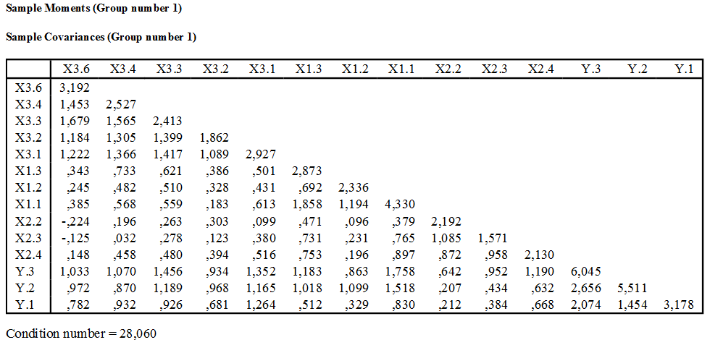

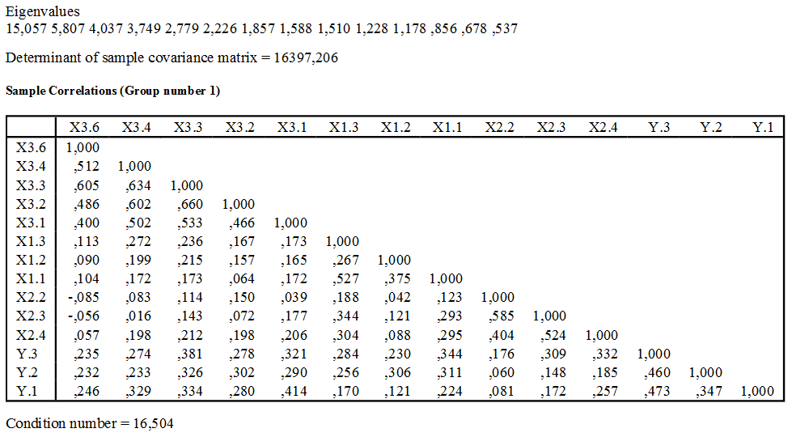

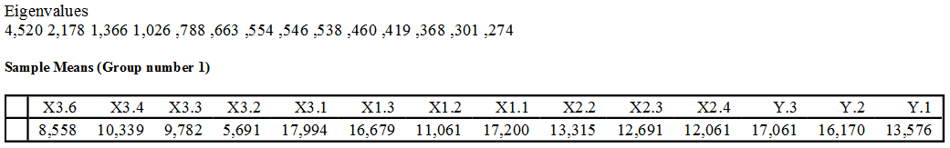

**Notes for Model (Default model)**

**Computation of degrees of freedom (Default model)**

|  |  |
| --- | --- |
| Number of distinct sample moments: | 119 |
| Number of distinct parameters to be estimated: | 48 |
| Degrees of freedom (119 - 48): | 71 |

**Result (Default model)**

Minimum was achieved

Chi-square = 85,496

Degrees of freedom = 71

Probability level = ,116

**Estimates (Group number 1 - Default model)**

**Scalar Estimates (Group number 1 - Default model)**

**Maximum Likelihood Estimates**

**Regression Weights: (Group number 1 - Default model)**

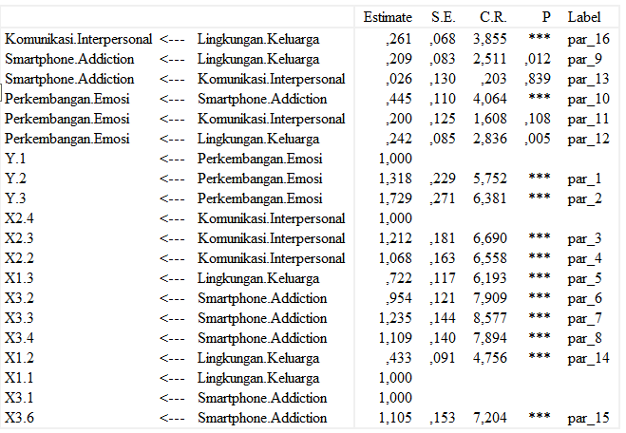

**Standardized Regression Weights: (Group number 1 - Default model)**

|  |  |  | Estimate |
| --- | --- | --- | --- |
| Komunikasi.Interpersonal | <--- | Lingkungan.Keluarga | ,463 |
| Smartphone.Addiction | <--- | Lingkungan.Keluarga | ,308 |
| Smartphone.Addiction | <--- | Komunikasi.Interpersonal | ,022 |
| Perkembangan.Emosi | <--- | Smartphone.Addiction | ,447 |
| Perkembangan.Emosi | <--- | Komunikasi.Interpersonal | ,167 |
| Perkembangan.Emosi | <--- | Lingkungan.Keluarga | ,358 |
| Y.1 | <--- | Perkembangan.Emosi | ,606 |
| Y.2 | <--- | Perkembangan.Emosi | ,607 |
| Y.3 | <--- | Perkembangan.Emosi | ,760 |
| X2.4 | <--- | Komunikasi.Interpersonal | ,619 |
| X2.3 | <--- | Komunikasi.Interpersonal | ,874 |
| X2.2 | <--- | Komunikasi.Interpersonal | ,652 |
| X1.3 | <--- | Lingkungan.Keluarga | ,683 |
| X3.2 | <--- | Smartphone.Addiction | ,759 |
| X3.3 | <--- | Smartphone.Addiction | ,863 |
| X3.4 | <--- | Smartphone.Addiction | ,757 |
| X1.2 | <--- | Lingkungan.Keluarga | ,454 |
| X1.1 | <--- | Lingkungan.Keluarga | ,770 |
| X3.1 | <--- | Smartphone.Addiction | ,634 |
| X3.6 | <--- | Smartphone.Addiction | ,671 |

**Intercepts: (Group number 1 - Default model)**

|  |  |  | Estimate | S.E. | C.R. | P | Label |
| --- | --- | --- | --- | --- | --- | --- | --- |
| Y.1 |  |  | 13,576 | ,139 | 97,530 | *** | par_17 |
| Y.2 |  |  | 16,170 | ,183 | 88,211 | *** | par_18 |
| Y.3 |  |  | 17,061 | ,192 | 88,864 | *** | par_19 |
| X2.4 |  |  | 12,061 | ,114 | 105,837 | *** | par_20 |
| X2.3 |  |  | 12,691 | ,098 | 129,661 | *** | par_21 |
| X2.2 |  |  | 13,315 | ,116 | 115,183 | *** | par_22 |
| X1.1 |  |  | 17,200 | ,162 | 105,857 | *** | par_23 |
| X1.2 |  |  | 11,061 | ,119 | 92,681 | *** | par_24 |
| X1.3 |  |  | 16,679 | ,132 | 126,023 | *** | par_25 |
| X3.1 |  |  | 17,994 | ,134 | 134,685 | *** | par_26 |
| X3.2 |  |  | 5,691 | ,107 | 53,408 | *** | par_27 |
| X3.3 |  |  | 9,782 | ,121 | 80,642 | *** | par_28 |
| X3.4 |  |  | 10,339 | ,124 | 83,290 | *** | par_29 |
| X3.6 |  |  | 8,558 | ,140 | 61,338 | *** | par_30 |

**Variances: (Group number 1 - Default model)**

|  |  |  | Estimate | S.E. | C.R. | P | Label |
| --- | --- | --- | --- | --- | --- | --- | --- |
| Lingkungan.Keluarga |  |  | 2,565 | ,561 | 4,573 | *** | par_31 |
| e26 |  |  | ,642 | ,169 | 3,791 | *** | par_32 |
| e24 |  |  | 1,058 | ,250 | 4,232 | *** | par_33 |
| e25 |  |  | ,540 | ,171 | 3,159 | ,002 | par_34 |
| e1 |  |  | 2,009 | ,270 | 7,434 | *** | par_35 |
| e2 |  |  | 3,480 | ,468 | 7,429 | *** | par_36 |
| e3 |  |  | 2,552 | ,491 | 5,200 | *** | par_37 |
| e6 |  |  | 1,313 | ,175 | 7,497 | *** | par_38 |
| e7 |  |  | ,372 | ,141 | 2,647 | ,008 | par_39 |
| e8 |  |  | 1,260 | ,177 | 7,109 | *** | par_40 |
| e10 |  |  | 1,764 | ,403 | 4,383 | *** | par_41 |
| e11 |  |  | 1,854 | ,224 | 8,259 | *** | par_42 |
| e12 |  |  | 1,534 | ,254 | 6,046 | *** | par_43 |
| e18 |  |  | 1,750 | ,213 | 8,218 | *** | par_44 |
| e19 |  |  | ,790 | ,108 | 7,323 | *** | par_45 |
| e20 |  |  | ,617 | ,115 | 5,380 | *** | par_46 |
| e21 |  |  | 1,080 | ,147 | 7,345 | *** | par_47 |
| e23 |  |  | 1,755 | ,218 | 8,030 | *** | par_48 |

**Squared Multiple Correlations: (Group number 1 - Default model)**

|  |  |  | Estimate |
| --- | --- | --- | --- |
| Komunikasi.Interpersonal |  |  | ,214 |
| Smartphone.Addiction |  |  | ,102 |
| Perkembangan.Emosi |  |  | ,538 |
| X3.6 |  |  | ,450 |
| X3.4 |  |  | ,573 |
| X3.3 |  |  | ,744 |
| X3.2 |  |  | ,576 |
| X3.1 |  |  | ,402 |
| X1.3 |  |  | ,466 |
| X1.2 |  |  | ,206 |
| X1.1 |  |  | ,593 |
| X2.2 |  |  | ,425 |
| X2.3 |  |  | ,763 |
| X2.4 |  |  | ,383 |
| Y.3 |  |  | ,578 |
| Y.2 |  |  | ,369 |
| Y.1 |  |  | ,368 |

**Matrices (Group number 1 - Default model)**

**Implied (for all variables) Covariances (Group number 1 - Default model)**

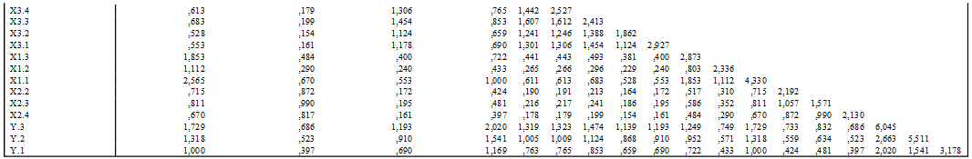

**Implied (for all variables) Correlations (Group number 1 - Default model)**

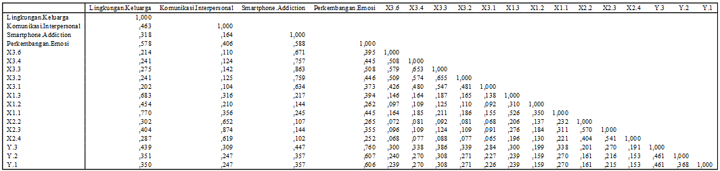

**Implied (for all variables) Means (Group number 1 - Default model)**



**Implied Covariances (Group number 1 - Default model)**

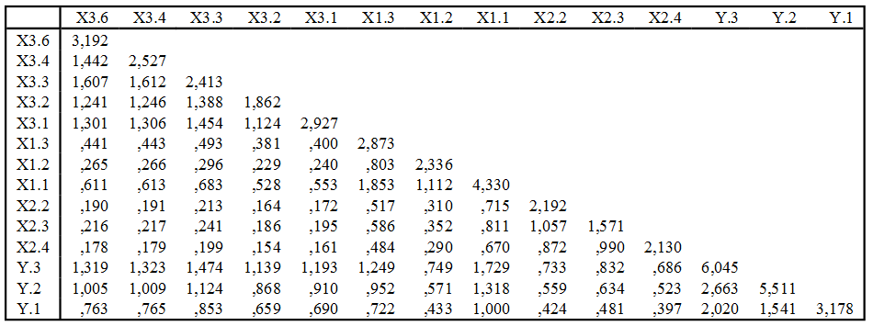

**Implied Correlations (Group number 1 - Default model)**

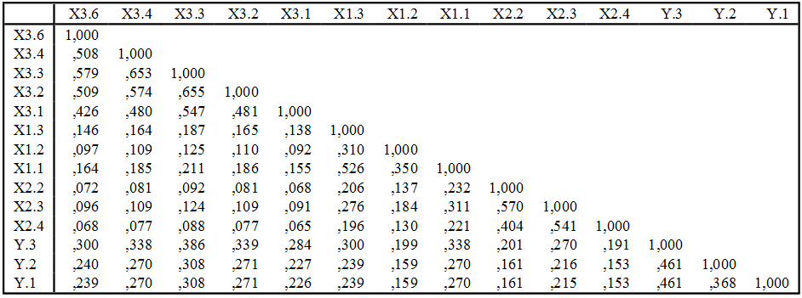

**Implied Means (Group number 1 - Default model)**



**Residual Covariances (Group number 1 - Default model)**

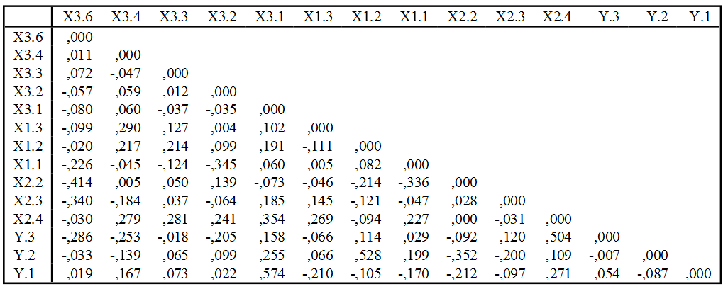

**Residual Means (Group number 1 - Default model)**



**Standardized Residual Covariances (Group number 1 - Default model)**

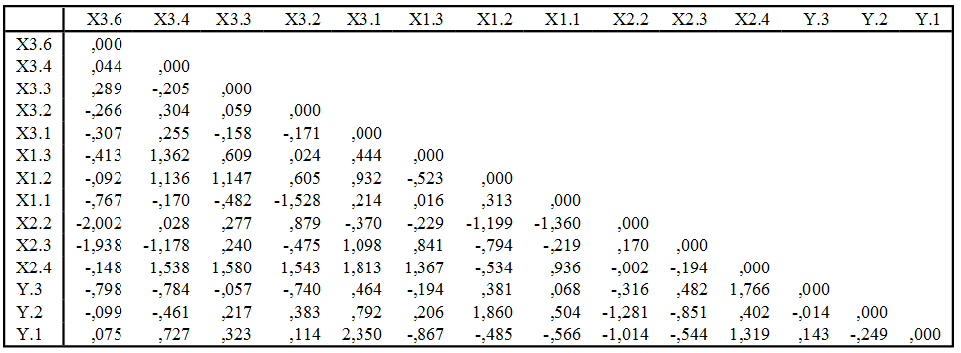

**Standardized Residual Means (Group number 1 - Default model)**



**Total Effects (Group number 1 - Default model)**

|  | Lingkungan.Keluarga | Komunikasi.Interpersonal | Smartphone.Addiction | Perkembangan.Emosi |
| --- | --- | --- | --- | --- |
| Komunikasi.Interpersonal | ,261 | ,000 | ,000 | ,000 |
| Smartphone.Addiction | ,216 | ,026 | ,000 | ,000 |
| Perkembangan.Emosi | ,390 | ,212 | ,445 | ,000 |
| X3.6 | ,238 | ,029 | 1,105 | ,000 |
| X3.4 | ,239 | ,029 | 1,109 | ,000 |
| X3.3 | ,266 | ,032 | 1,235 | ,000 |
| X3.2 | ,206 | ,025 | ,954 | ,000 |
| X3.1 | ,216 | ,026 | 1,000 | ,000 |
| X1.3 | ,722 | ,000 | ,000 | ,000 |
| X1.2 | ,433 | ,000 | ,000 | ,000 |
| X1.1 | 1,000 | ,000 | ,000 | ,000 |
| X2.2 | ,279 | 1,068 | ,000 | ,000 |
| X2.3 | ,316 | 1,212 | ,000 | ,000 |
| X2.4 | ,261 | 1,000 | ,000 | ,000 |
| Y.3 | ,674 | ,366 | ,770 | 1,729 |
| Y.2 | ,514 | ,279 | ,587 | 1,318 |
| Y.1 | ,390 | ,212 | ,445 | 1,000 |

**Standardized Total Effects (Group number 1 - Default model)**

|  | Lingkungan.Keluarga | Komunikasi.Interpersonal | Smartphone.Addiction | Perkembangan.Emosi |
| --- | --- | --- | --- | --- |
| Komunikasi.Interpersonal | ,463 | ,000 | ,000 | ,000 |
| Smartphone.Addiction | ,318 | ,022 | ,000 | ,000 |
| Perkembangan.Emosi | ,578 | ,177 | ,447 | ,000 |
| X3.6 | ,214 | ,015 | ,671 | ,000 |
| X3.4 | ,241 | ,017 | ,757 | ,000 |
| X3.3 | ,275 | ,019 | ,863 | ,000 |
| X3.2 | ,241 | ,017 | ,759 | ,000 |
| X3.1 | ,202 | ,014 | ,634 | ,000 |
| X1.3 | ,683 | ,000 | ,000 | ,000 |
| X1.2 | ,454 | ,000 | ,000 | ,000 |
| X1.1 | ,770 | ,000 | ,000 | ,000 |
| X2.2 | ,302 | ,652 | ,000 | ,000 |
| X2.3 | ,404 | ,874 | ,000 | ,000 |
| X2.4 | ,287 | ,619 | ,000 | ,000 |
| Y.3 | ,439 | ,135 | ,340 | ,760 |
| Y.2 | ,351 | ,108 | ,271 | ,607 |
| Y.1 | ,350 | ,107 | ,271 | ,606 |

**Direct Effects (Group number 1 - Default model)**

|  | Lingkungan.Keluarga | Komunikasi.Interpersonal | Smartphone.Addiction | Perkembangan.Emosi |
| --- | --- | --- | --- | --- |
| Komunikasi.Interpersonal | ,261 | ,000 | ,000 | ,000 |
| Smartphone.Addiction | ,209 | ,026 | ,000 | ,000 |
| Perkembangan.Emosi | ,242 | ,200 | ,445 | ,000 |
| X3.6 | ,000 | ,000 | 1,105 | ,000 |
| X3.4 | ,000 | ,000 | 1,109 | ,000 |
| X3.3 | ,000 | ,000 | 1,235 | ,000 |
| X3.2 | ,000 | ,000 | ,954 | ,000 |
| X3.1 | ,000 | ,000 | 1,000 | ,000 |
| X1.3 | ,722 | ,000 | ,000 | ,000 |
| X1.2 | ,433 | ,000 | ,000 | ,000 |
| X1.1 | 1,000 | ,000 | ,000 | ,000 |
| X2.2 | ,000 | 1,068 | ,000 | ,000 |
| X2.3 | ,000 | 1,212 | ,000 | ,000 |
| X2.4 | ,000 | 1,000 | ,000 | ,000 |
| Y.3 | ,000 | ,000 | ,000 | 1,729 |
| Y.2 | ,000 | ,000 | ,000 | 1,318 |
| Y.1 | ,000 | ,000 | ,000 | 1,000 |

**Standardized Direct Effects (Group number 1 - Default model)**

|  | Lingkungan.Keluarga | Komunikasi.Interpersonal | Smartphone.Addiction | Perkembangan.Emosi |
| --- | --- | --- | --- | --- |
| Komunikasi.Interpersonal | ,463 | ,000 | ,000 | ,000 |
| Smartphone.Addiction | ,308 | ,022 | ,000 | ,000 |
| Perkembangan.Emosi | ,358 | ,167 | ,447 | ,000 |
| X3.6 | ,000 | ,000 | ,671 | ,000 |
| X3.4 | ,000 | ,000 | ,757 | ,000 |
| X3.3 | ,000 | ,000 | ,863 | ,000 |
| X3.2 | ,000 | ,000 | ,759 | ,000 |
| X3.1 | ,000 | ,000 | ,634 | ,000 |
| X1.3 | ,683 | ,000 | ,000 | ,000 |
| X1.2 | ,454 | ,000 | ,000 | ,000 |
| X1.1 | ,770 | ,000 | ,000 | ,000 |
| X2.2 | ,000 | ,652 | ,000 | ,000 |
| X2.3 | ,000 | ,874 | ,000 | ,000 |
| X2.4 | ,000 | ,619 | ,000 | ,000 |
| Y.3 | ,000 | ,000 | ,000 | ,760 |
| Y.2 | ,000 | ,000 | ,000 | ,607 |
| Y.1 | ,000 | ,000 | ,000 | ,606 |

**Indirect Effects (Group number 1 - Default model)**

|  | Lingkungan.Keluarga | Komunikasi.Interpersonal | Smartphone.Addiction | Perkembangan.Emosi |
| --- | --- | --- | --- | --- |
| Komunikasi.Interpersonal | ,000 | ,000 | ,000 | ,000 |
| Smartphone.Addiction | ,007 | ,000 | ,000 | ,000 |
| Perkembangan.Emosi | ,148 | ,012 | ,000 | ,000 |
| X3.6 | ,238 | ,029 | ,000 | ,000 |
| X3.4 | ,239 | ,029 | ,000 | ,000 |
| X3.3 | ,266 | ,032 | ,000 | ,000 |
| X3.2 | ,206 | ,025 | ,000 | ,000 |
| X3.1 | ,216 | ,026 | ,000 | ,000 |
| X1.3 | ,000 | ,000 | ,000 | ,000 |
| X1.2 | ,000 | ,000 | ,000 | ,000 |
| X1.1 | ,000 | ,000 | ,000 | ,000 |
| X2.2 | ,279 | ,000 | ,000 | ,000 |
| X2.3 | ,316 | ,000 | ,000 | ,000 |
| X2.4 | ,261 | ,000 | ,000 | ,000 |
| Y.3 | ,674 | ,366 | ,770 | ,000 |
| Y.2 | ,514 | ,279 | ,587 | ,000 |
| Y.1 | ,390 | ,212 | ,445 | ,000 |

**Standardized Indirect Effects (Group number 1 - Default model)**

|  | Lingkungan.Keluarga | Komunikasi.Interpersonal | Smartphone.Addiction | Perkembangan.Emosi |
| --- | --- | --- | --- | --- |
| Komunikasi.Interpersonal | ,000 | ,000 | ,000 | ,000 |
| Smartphon.Addiction | ,010 | ,000 | ,000 | ,000 |
| Perkembangan.Emosi | ,220 | ,010 | ,000 | ,000 |
| X3.6 | ,214 | ,015 | ,000 | ,000 |
| X3.4 | ,241 | ,017 | ,000 | ,000 |
| X3.3 | ,275 | ,019 | ,000 | ,000 |
| X3.2 | ,241 | ,017 | ,000 | ,000 |
| X3.1 | ,202 | ,014 | ,000 | ,000 |
| X1.3 | ,000 | ,000 | ,000 | ,000 |
| X1.2 | ,000 | ,000 | ,000 | ,000 |
| X1.1 | ,000 | ,000 | ,000 | ,000 |
| X2.2 | ,302 | ,000 | ,000 | ,000 |
| X2.3 | ,404 | ,000 | ,000 | ,000 |
| X2.4 | ,287 | ,000 | ,000 | ,000 |
| Y.3 | ,439 | ,135 | ,340 | ,000 |
| Y.2 | ,351 | ,108 | ,271 | ,000 |
| Y.1 | ,350 | ,107 | ,271 | ,000 |

**Standardized Regression Weights: (Group number 1 - Default model)**

|  |  |  | Estimate |
| --- | --- | --- | --- |
| Komunikasi.Interpersonal | <--- | Lingkungan.Keluarga | ,463 |
| Smartphone.Addiction | <--- | Lingkungan.Keluarga | ,308 |
| Smartphone.Addiction | <--- | Komunikasi.Interpersonal | ,022 |
| Perkembangan.Emosi | <--- | Smartphone.Addiction | ,447 |
| Perkembangan.Emosi | <--- | Komunikasi.Interpersonal | ,167 |
| Perkembangan.Emosi | <--- | Lingkungan.Keluarga | ,358 |
| Y.1 | <--- | Perkembangan.Emosi | ,606 |
| Y.2 | <--- | Perkembangan.Emosi | ,607 |
| Y.3 | <--- | Perkembangan.Emosi | ,760 |
| X2.4 | <--- | Komunikasi.Interpersonal | ,619 |
| X2.3 | <--- | Komunikasi.Interpersonal | ,874 |
| X2.2 | <--- | Komunikasi.Interpersonal | ,652 |
| X1.3 | <--- | Lingkungan.Keluarga | ,683 |
| X3.2 | <--- | Smartphone.Addiction | ,759 |
| X3.3 | <--- | Smartphone.Addiction | ,863 |
| X3.4 | <--- | Smartphone.Addiction | ,757 |
| X1.2 | <--- | Lingkungan.Keluarga | ,454 |
| X1.1 | <--- | Lingkungan.Keluarga | ,770 |
| X3.1 | <--- | Smartphone.Addiction | ,634 |
| X3.6 | <--- | Smartphone.Addiction | ,671 |

**Intercepts: (Group number 1 - Default model)**

|  |  |  | Estimate | S.E. | C.R. | P | Label |
| --- | --- | --- | --- | --- | --- | --- | --- |
| Y.1 |  |  | 13,576 | ,139 | 97,530 | *** | par_17 |
| Y.2 |  |  | 16,170 | ,183 | 88,211 | *** | par_18 |
| Y.3 |  |  | 17,061 | ,192 | 88,864 | *** | par_19 |
| X2.4 |  |  | 12,061 | ,114 | 105,837 | *** | par_20 |
| X2.3 |  |  | 12,691 | ,098 | 129,661 | *** | par_21 |
| X2.2 |  |  | 13,315 | ,116 | 115,183 | *** | par_22 |
| X1.1 |  |  | 17,200 | ,162 | 105,857 | *** | par_23 |
| X1.2 |  |  | 11,061 | ,119 | 92,681 | *** | par_24 |
| X1.3 |  |  | 16,679 | ,132 | 126,023 | *** | par_25 |
| X3.1 |  |  | 17,994 | ,134 | 134,685 | *** | par_26 |
| X3.2 |  |  | 5,691 | ,107 | 53,408 | *** | par_27 |
| X3.3 |  |  | 9,782 | ,121 | 80,642 | *** | par_28 |
| X3.4 |  |  | 10,339 | ,124 | 83,290 | *** | par_29 |
| X3.6 |  |  | 8,558 | ,140 | 61,338 | *** | par_30 |

**Variances: (Group number 1 - Default model)**

|  |  |  | Estimate | S.E. | C.R. | P | Label |
| --- | --- | --- | --- | --- | --- | --- | --- |
| Lingkungan.Keluarga |  |  | 2,565 | ,561 | 4,573 | *** | par_31 |
| e26 |  |  | ,642 | ,169 | 3,791 | *** | par_32 |
| e24 |  |  | 1,058 | ,250 | 4,232 | *** | par_33 |
| e25 |  |  | ,540 | ,171 | 3,159 | ,002 | par_34 |
| e1 |  |  | 2,009 | ,270 | 7,434 | *** | par_35 |
| e2 |  |  | 3,480 | ,468 | 7,429 | *** | par_36 |
| e3 |  |  | 2,552 | ,491 | 5,200 | *** | par_37 |
| e6 |  |  | 1,313 | ,175 | 7,497 | *** | par_38 |
| e7 |  |  | ,372 | ,141 | 2,647 | ,008 | par_39 |
| e8 |  |  | 1,260 | ,177 | 7,109 | *** | par_40 |
| e10 |  |  | 1,764 | ,403 | 4,383 | *** | par_41 |
| e11 |  |  | 1,854 | ,224 | 8,259 | *** | par_42 |
| e12 |  |  | 1,534 | ,254 | 6,046 | *** | par_43 |
| e18 |  |  | 1,750 | ,213 | 8,218 | *** | par_44 |
| e19 |  |  | ,790 | ,108 | 7,323 | *** | par_45 |
| e20 |  |  | ,617 | ,115 | 5,380 | *** | par_46 |
| e21 |  |  | 1,080 | ,147 | 7,345 | *** | par_47 |
| e23 |  |  | 1,755 | ,218 | 8,030 | *** | par_48 |

**Squared Multiple Correlations: (Group number 1 - Default model)**

|  |  |  | Estimate |
| --- | --- | --- | --- |
| Komunikasi.Interpersonal |  |  | ,214 |
| Smartphone.Addiction |  |  | ,102 |
| Perkembangan.Emosi |  |  | ,538 |
| X3.6 |  |  | ,450 |
| X3.4 |  |  | ,573 |
| X3.3 |  |  | ,744 |
| X3.2 |  |  | ,576 |
| X3.1 |  |  | ,402 |
| X1.3 |  |  | ,466 |
| X1.2 |  |  | ,206 |
| X1.1 |  |  | ,593 |
| X2.2 |  |  | ,425 |
| X2.3 |  |  | ,763 |
| X2.4 |  |  | ,383 |
| Y.3 |  |  | ,578 |
| Y.2 |  |  | ,369 |
| Y.1 |  |  | ,368 |

**Matrices (Group number 1 - Default model)**

**Implied (for all variables) Covariances (Group number 1 - Default model)**

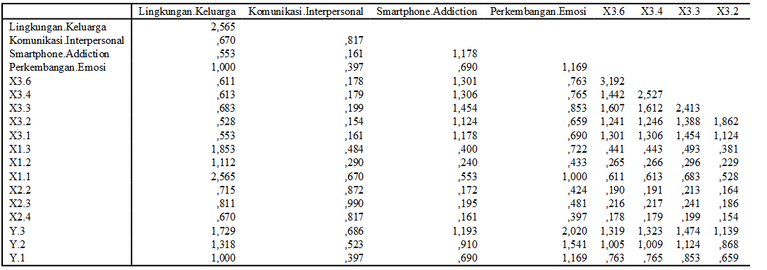

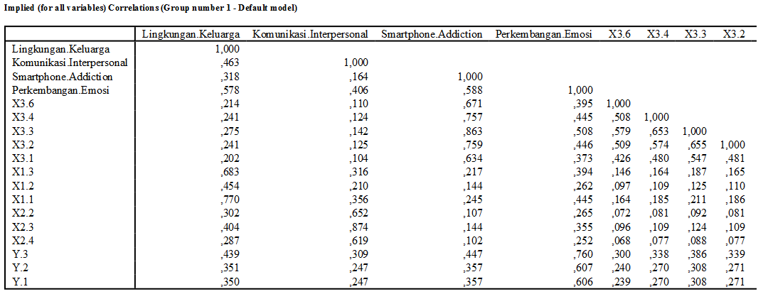



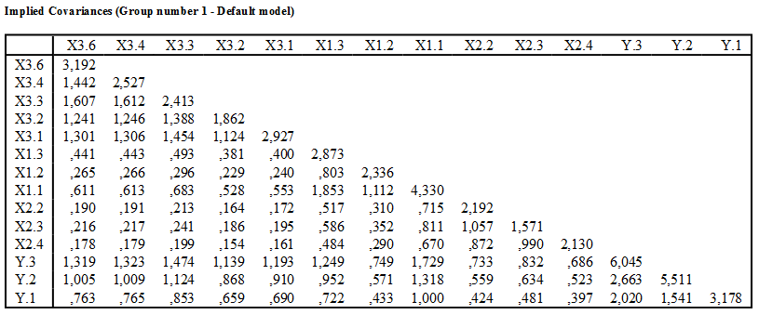

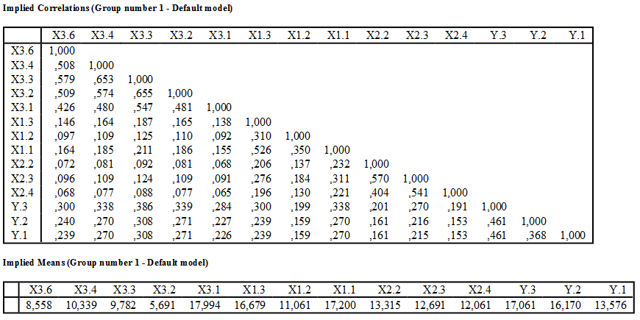

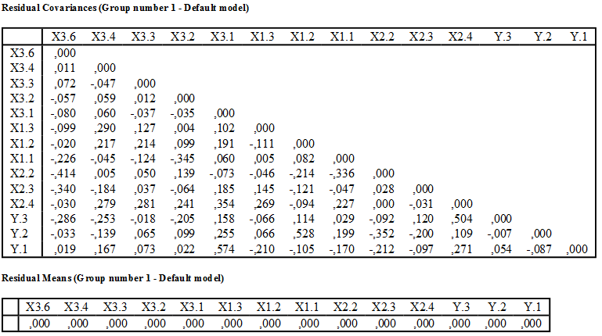

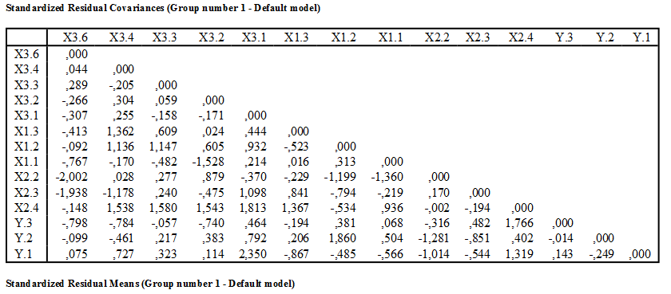

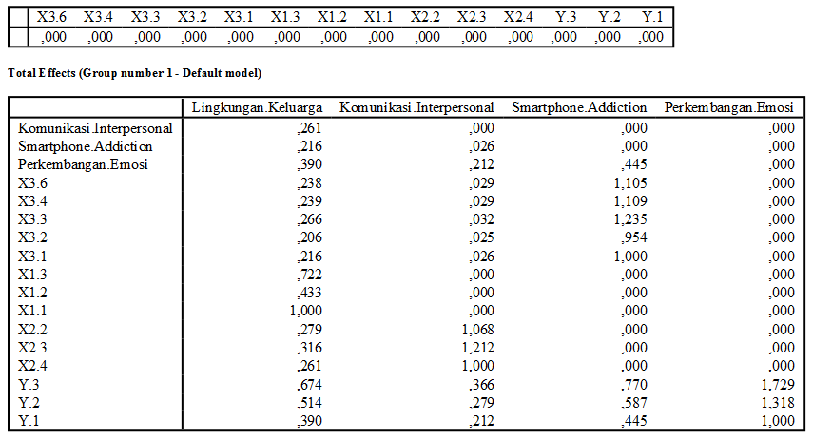

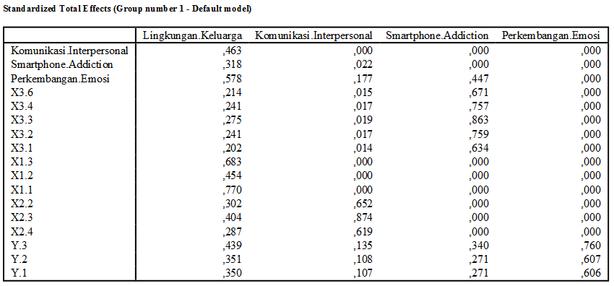

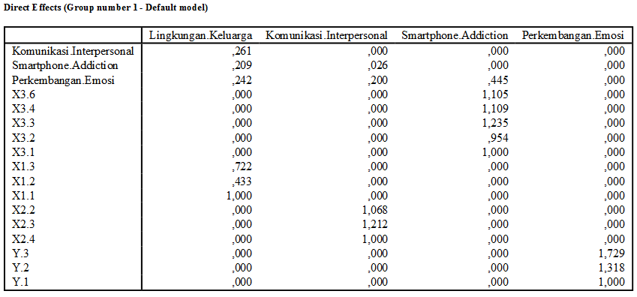

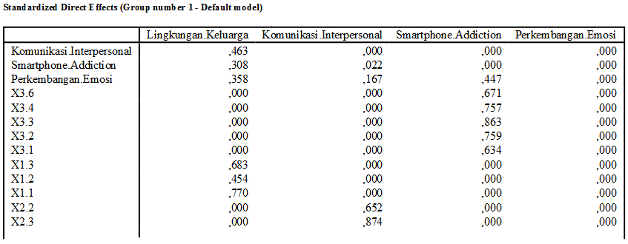

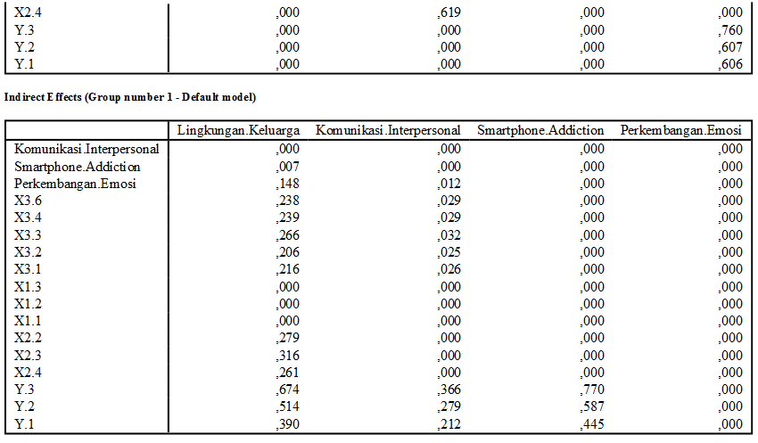

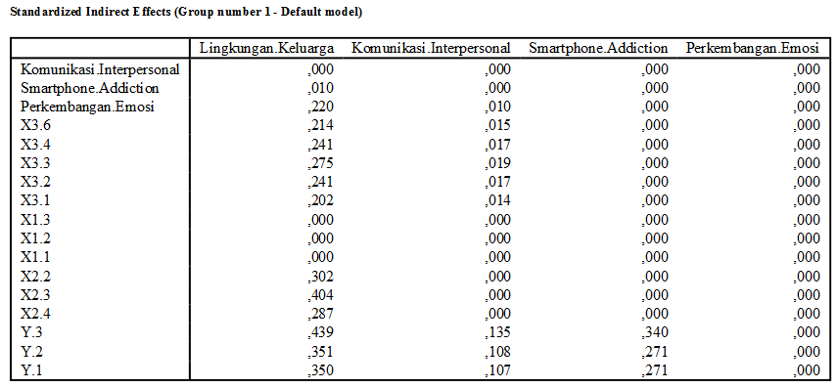

**Modification Indices (Group number 1 - Default model)**

**Covariances: (Group number 1 - Default model)**

|  |  |  | M.I. | Par Change |
| --- | --- | --- | --- | --- |
| e23 | <--> | e26 | 6,412 | -,257 |
| e8 | <--> | e19 | 4,837 | ,200 |
| e7 | <--> | e21 | 6,047 | -,199 |
| e6 | <--> | e24 | 4,077 | ,214 |
| e2 | <--> | e11 | 4,262 | ,454 |
| e1 | <--> | e18 | 6,382 | ,414 |

**Variances: (Group number 1 - Default model)**

|  |  |  | M.I. | Par Change |
| --- | --- | --- | --- | --- |

**Regression Weights: (Group number 1 - Default model)**

|  |  |  | M.I. | Par Change |
| --- | --- | --- | --- | --- |
| X3.6 | <--- | Komunikasi.Interpersonal | 7,182 | -,355 |
| X2.4 | <--- | Smartphone.Addiction | 5,478 | ,217 |
| X2.4 | <--- | Perkembangan.Emosi | 5,672 | ,237 |

**Means: (Group number 1 - Default model)**

|  |  |  | M.I. | Par Change |
| --- | --- | --- | --- | --- |

**Intercepts: (Group number 1 - Default model)**

|  |  |  | M.I. | Par Change |
| --- | --- | --- | --- | --- |

**Model Fit Summary**

**CMIN**

| Model | NPAR | CMIN | DF | P | CMIN/DF |
| --- | --- | --- | --- | --- | --- |
| Default model | 48 | 85,496 | 71 | ,116 | 1,204 |
| Saturated model | 119 | ,000 | 0 |  |  |
| Independence model | 28 | 817,206 | 91 | ,000 | 8,980 |

**RMR, GFI**

| Model | RMR | GFI | AGFI | PGFI |
| --- | --- | --- | --- | --- |
| Default model | ,176 | ,934 | ,902 | ,631 |
| Saturated model | ,000 | 1,000 |  |  |
| Independence model | ,874 | ,456 | ,372 | ,395 |

**Baseline Comparisons**

| Model | NFI Delta1 | RFI rho1 | IFI Delta2 | TLI rho2 | CFI |
| --- | --- | --- | --- | --- | --- |
| Default model | ,895 | ,866 | ,981 | ,974 | ,980 |
| Saturated model | 1,000 |  | 1,000 |  | 1,000 |
| Independence model | ,000 | ,000 | ,000 | ,000 | ,000 |

**Parsimony-Adjusted Measures**

| Model | PRATIO | PNFI | PCFI |
| --- | --- | --- | --- |
| Default model | ,780 | ,699 | ,765 |
| Saturated model | ,000 | ,000 | ,000 |
| Independence model | 1,000 | ,000 | ,000 |

**NCP**

| Model | NCP | LO 90 | HI 90 |
| --- | --- | --- | --- |
| Default model | 14,496 | ,000 | 41,927 |
| Saturated model | ,000 | ,000 | ,000 |
| Independence model | 726,206 | 638,508 | 821,358 |

**FMIN**

| Model | FMIN | F0 | LO 90 | HI 90 |
| --- | --- | --- | --- | --- |
| Default model | ,521 | ,088 | ,000 | ,256 |
| Saturated model | ,000 | ,000 | ,000 | ,000 |
| Independence model | 4,983 | 4,428 | 3,893 | 5,008 |

**RMSEA**

| Model | RMSEA | LO 90 | HI 90 | PCLOSE |
| --- | --- | --- | --- | --- |
| Default model | ,035 | ,000 | ,060 | ,817 |
| Independence model | ,221 | ,207 | ,235 | ,000 |

**AIC**

| Model | AIC | BCC | BIC | CAIC |
| --- | --- | --- | --- | --- |
| Default model | 181,496 | 191,160 |  |  |
| Saturated model | 238,000 | 261,960 |  |  |
| Independence model | 873,206 | 878,844 |  |  |

**ECVI**

| Model | ECVI | LO 90 | HI 90 | MECVI |
| --- | --- | --- | --- | --- |
| Default model | 1,107 | 1,018 | 1,274 | 1,166 |
| Saturated model | 1,451 | 1,451 | 1,451 | 1,597 |
| Independence model | 5,324 | 4,790 | 5,905 | 5,359 |

**HOELTER**

| Model | HOELTER .05 | HOELTER .01 |
| --- | --- | --- |
| Default model | 176 | 195 |
| Independence model | 23 | 26 |